Guide to Microsoft System Center Management Pack for Microsoft Azure SQL Database
Microsoft Corporation
Published: May, 2017

The Operations Manager team encourages you to provide any feedbacks on the management pack by sending them to sqlmpsfeedback@microsoft.com.

Copyright
This document is provided "as is". Information and views expressed in this document, including URL and other Internet website references, may change without notice. You bear the risk of using it.
Some examples depicted herein are provided for illustration only and are fictitious. No real association or connection is intended or should be inferred.
This document does not provide you with any legal rights to any intellectual property in any Microsoft product. You may copy and use this document for your internal, reference purposes. You may modify this document for your internal, reference purposes.
© 2017 Microsoft Corporation. All rights reserved.
Microsoft, Active Directory, Windows, and Windows Server are trademarks of the Microsoft group of companies.
All other trademarks are property of their respective owners.
Contents

Guide to Microsoft System Center Management Pack for Microsoft Azure SQL Database 5
Document Version 5
Changes History 5
Introduction to the Management Pack Guide 6
Supported Configurations 7
Get Started 7
Files in this Management Pack 7
Import the Management Pack 8
Create Microsoft Azure SQL Database Run As Accounts 8
Microsoft Azure SQL Database Add Monitoring Wizard 11
Create a New Management Pack for Customizations 26
Customize Microsoft Azure SQL Database Management Pack 27
Security Considerations 27
Run As Accounts 27
Low-Privilege Configuration 27
Performance and Billing Considerations 28
Understand Microsoft Azure SQL Database Management Pack 29
Classes and Inheritance Diagram 29
Class Relationships 30
Objects the Management Pack Discovers 30
How Health Rolls Up 31
Key Monitoring Scenarios 31
Service Availability Monitoring 32
Service Performance Monitoring 32
Service Performance Collection 32
Database Availability Monitoring 32
Database Performance Monitoring 32
Database Performance Collection 32
Custom User Query Monitoring 33
View Information in the Operations Console 42
Database Views 43
Server Views 44
Appendix: Known Issues and Troubleshooting 45
Appendix: Disabled Monitors 47
Appendix: Management Pack Objects and Workflows 48

Guide to Microsoft System Center Management Pack for Microsoft Azure SQL Database

Document Version
This guide is based on version 6.7.28.0 RTM of the management pack.

Changes History

Release date | Changes
May, 2017 (version 6.7.28.0 RTM) | - Due to performance problems, several monitors and performance rules were enabled for getting information via T-SQL queries only (the affected metrics are as follows: Failed Connections, Blocked Connections, Successful Connections, Deadlocks Count)  - Fixed Azure SQL DB: DB Transactions Locks Count rule and Transaction Locks Count monitor  - Fixed Microsoft Azure SQL Database Event Log Collection Target Management Service Discovery  - Fixed Server Exclude list filter: servername could not contain whitespaces  - Fixed the display strings, implemented appropriate Azure Portal naming style
March, 2017 (version 6.7.25.0 CTP2) | - Implemented performance improvements  - Improved error handling in Add Monitoring Wizard  - Fixed issue: "Collect Elastic Database Pool Number of Databases" rule does not collect performance data if REST monitoring is used  - Fixed issue: "Operations Manager Expression Filter Module" error messages appear in the Operations Manager event log
December, 2016 (version 6.7.11.0) | - Azure Resource Manager is now supported: the previous versions of the Management Pack used T-SQL queries to SQL Server system views to get information on the databases health and performance; now, the Management Pack can also get this information from Azure REST API (this is a preferred option)  - Multiple subscriptions and multiple servers are now supported  - Added support of Azure AD authentication  - Added regular expression filtering capability for Azure SQL Database instances and Elastic Pools  - Improved monitoring efficiency: monitoring target is now defined by monitoring pool; WatcherNode class is considered to be deprecated  - Improved SCOM Add Monitoring Wizard to reflect the new features of the Management Pack  - Added health monitoring for Database Geo-Replication  - Added health monitoring for Elastic Pools  - Added monitoring for “Average DTU utilization percentage” metric  - Fixed issue: some rules work only if more than 1% of Microsoft Azure SQL Database space is used  - Introduced performance improvements to the Management Pack  - Optimized performance rules notation: all Object Names are standardized; Instance Names are not used anymore  - Updated the guide to reflect all the changes  - Updated the visualization library
June, 2016 (version 1.6.1.0) | - Added Dashboards  - Added a number of new monitors and rules, including the following:  - CPU Usage (%)  - Workers Usage (%)  - Log write (%)  - Data I/O (%)  - Sessions (%)  - Count Failed Connection  - Count Successful Connection  - Count Connection Blocked by Firewall  - Count of Deadlock  - Count Throttling long transaction  - Count Connection Failed  - XTP Storage (In-memory OLTP Storage, %)  - Deprecated Collect Microsoft Azure SQL Database Internal/External Network Egress/Ingress performance rules  - Deprecated SQL Azure Federation and Federation member workflows  - Implemented rebranding: the management pack and some workflow names have been changed
May, 2013 | Original release of this management pack

Introduction to the Management Pack Guide
Microsoft Azure SQL Database Management Pack provides both proactive and reactive monitoring of Microsoft Azure SQL Database.
The monitoring provided by this management pack includes availability, performance data collection and default thresholds. You can integrate the monitoring of Microsoft Azure SQL Database components into your hybrid cloud service monitoring scenarios.
In addition to health monitoring capabilities, this management pack includes extensive knowledge and views that enable near real-time diagnosis and resolution of the detected issues.
Note: This management pack is not part of System Center management pack for Microsoft Azure.

Supported Configurations
Microsoft Azure SQL Database Management Pack is designed for the System Center Operations Manager 2012. Any versions prior to Operations Manager 2012 are not supported.
This management pack has been tested on Windows Server 2012 R2. Other versions of Windows operating system have not been tested.
The current version of the management pack supports upgrade from 1.6.x versions of the management pack. At that, the existing Run As configuration remains in operation.
Note: installation of .NET Framework 4.6.1 (at least) is required.
Important
This Management Pack is verified to handle monitoring of 2000 databases in a single management group.

Get Started
Microsoft Azure SQL Database Management Pack can monitor Microsoft Azure SQL Database, which appears to be a Microsoft’s cloud-based database offering. Use the Authoring pane of the Operations Console to enable discovery of Microsoft Azure SQL Database servers and databases hosted on those servers. For more information about enabling object discovery, see Microsoft Azure SQL Database Add Monitoring Wizard section below.

Files in this Management Pack
The following table describes the files included in this management pack.
File | Display name | Description
Microsoft.SqlServer.Azure.mpb | Microsoft Azure SQL Database Monitoring | Contains definitions for object types and groups that are specific to Microsoft Azure SQL Database. It contains a template, which can be used to generate a management pack for discovering a Microsoft Azure SQL Database server. It contains the discovery logic to detect databases hosted by the discovered servers. Provides all server and database monitoring for Microsoft Azure SQL Database.
Microsoft.SqlServer.Azure.Presentation.mp | Microsoft Azure SQL Database Monitoring Presentation | Microsoft Azure SQL Database Presentation management pack. This management pack adds Microsoft Azure SQL Database Dashboard.
Microsoft.SqlServer.UserMonitoring.mpb | Microsoft Azure SQL Database User Monitoring | Provides User Monitoring for Microsoft Azure SQL Database
Microsoft.SQLServer.Generic.Dashboards.mp | Microsoft SQL Server Generic Dashboards | Generic Dashboards Management Pack
Microsoft.SQLServer.Generic.Presentation.mp | Microsoft SQL Server Generic Presentation | Generic Presentation management pack.

Import the Management Pack
For more information about importing a management pack, see How to Import an Operations Manager Management Pack article.
Import Microsoft.SqlServer.Azure.mpb using the Administration pane in the Operations Console. After running the installer, the management pack is typically located on the system drive in \Program Files\System Center Management Packs folder.

Create Microsoft Azure SQL Database Run As Accounts
To monitor Microsoft Azure SQL Database servers, first create one or more Simple or Basic authentication Run As accounts, which contain the credentials for accessing the servers. To do this, perform the following steps:
- In SCOM Console, navigate to Administration | Run As Configuration | Accounts, right-click it and select Create Run As Account…
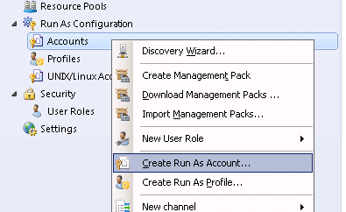

- On the Introduction page, click Next button.

- On the General Properties page, select Simple Authentication in Run As account type combo box, populate Display name and click Next button.

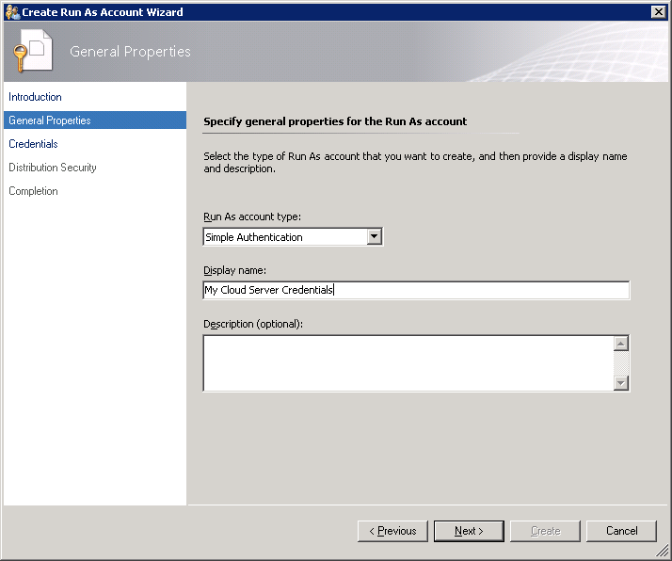

- On the Credentials page, populate Account name and Password with the credentials that will be used to connect to Microsoft Azure SQL Database cloud service and click Next button.
For more information on this credentials, see Low-Privilege Configuration section.

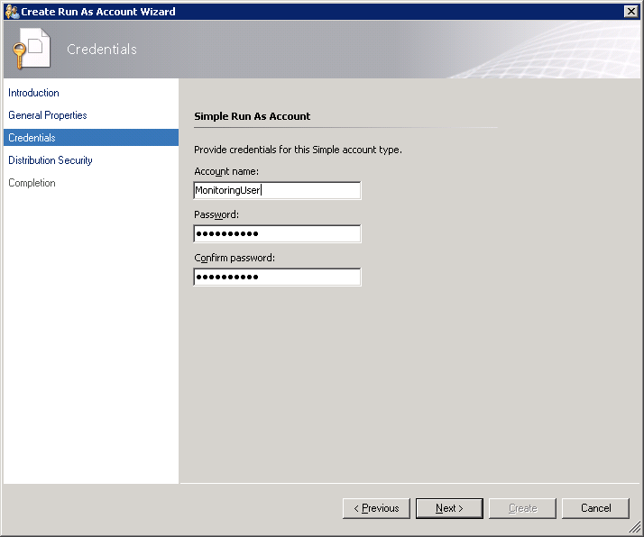

- On the Distribution Security page, select More secure option and click Create button.
You can use Less secure option and skip steps 7 – 8 if your environment is secure enough.

- Click Close to close the window.
If you used Less secure option on step 5, you can skip the next steps.
- Right-click the newly created account and select Properties.

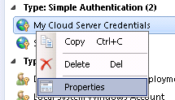

- Navigate to Distribution tab and add the SCOM Agent that you wish to use as a Watcher Node to monitor Microsoft Azure SQL Database cloud service.

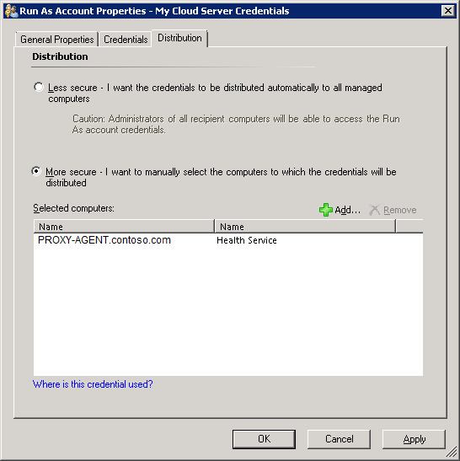
See Managing Run As Accounts and Profiles article for more information about Run As accounts.

Microsoft Azure SQL Database Add Monitoring Wizard
To begin monitoring a Microsoft Azure SQL Database cloud service, perform the following steps:
In SCOM Console, navigate to Authoring | Management Pack Templates, right-click Microsoft Azure SQL Database Monitoring and select Add Monitoring Wizard…

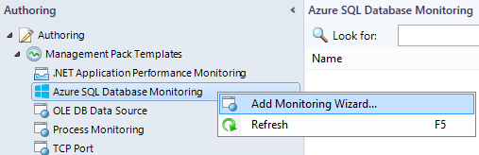
In Monitoring Type window, select Azure SQL Database Monitoring and click Next button.
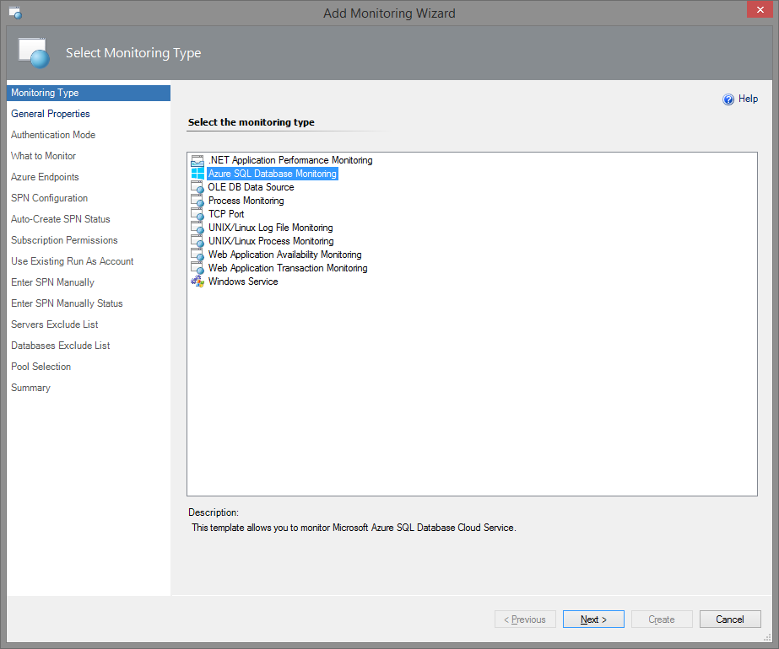
In General Properties window, you must provide your template Name and Description, as well as Select destination management pack where the template will be stored.

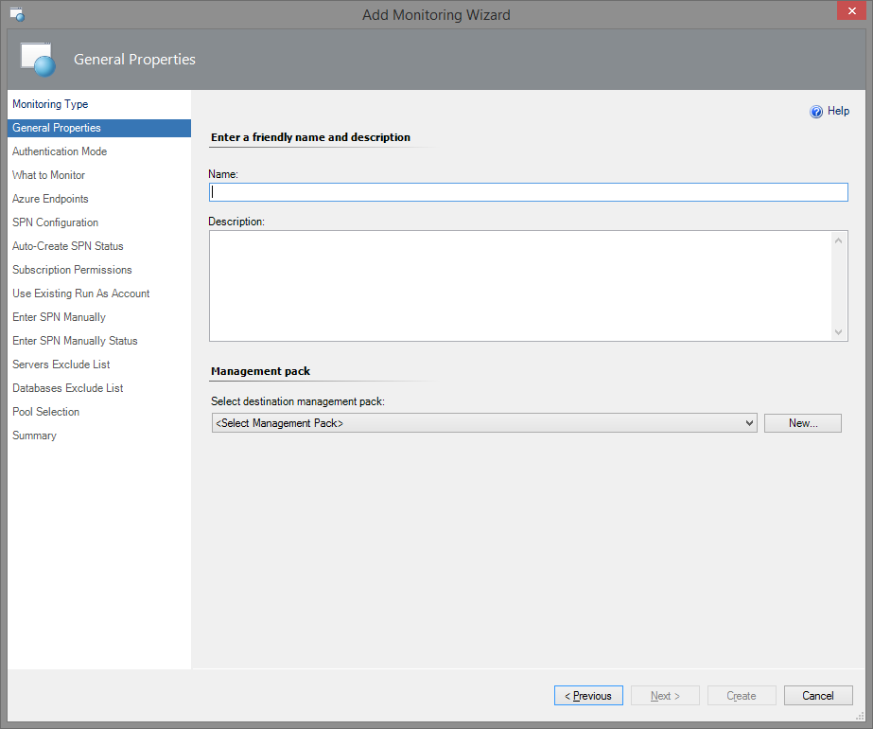
If you do not have a management pack for this purpose, you can create a new one by clicking New… button.
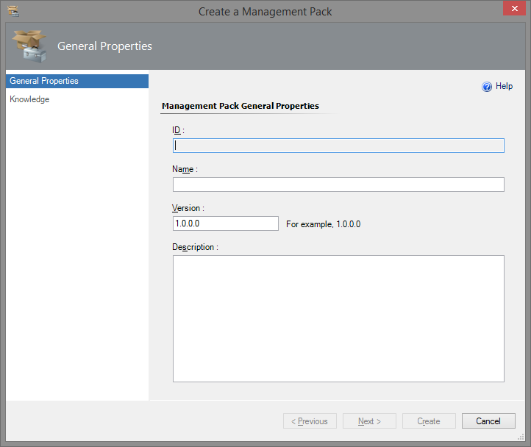
Note: It is recommended to use a new MP for the template.
In the Authentication Mode window, select an authentication mode for the monitoring.

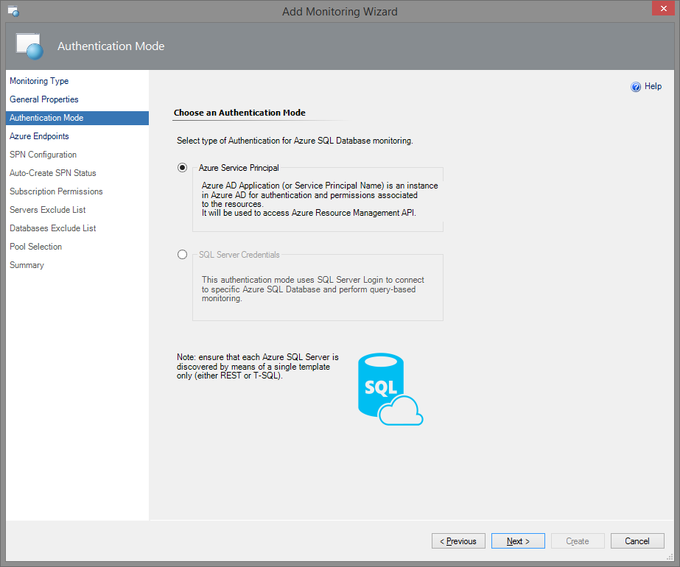
There are two authentication modes available: authentication by means of Azure Service Principal Name (SPN) and by means of SQL Server Credentials.
SQL Server Credentials authentication mode is meant for monitoring specific Azure SQL Database Servers. At that, Transact-SQL is used. If you choose this authentication mode and configure the permissions properly, the monitoring workflows (discoveries, rules, monitors) use T-SQL queries in datasources for their work.
Workflow datasource creates a new SQL connection for every pair of SQL Server Credentials (login/password).
SQL connections are counted for Database Transaction Units; consequently, they affect the bill (see Azure SQL Database resource limits article for more details).
While configuring the management pack template, you should manually enter SQL credentials for each Azure SQL Server and appropriate Run As account. Make sure that the provided SQL Credentials authorise the System Administrator rights.
Azure Service Principal Name authentication mode is meant for wider range of monitoring targets. Therefore, this mode is recommended to use while working with this management pack. In this case, REST is used by default. However, Transact-SQL monitoring is also available. Make sure the corresponding box is checked while configuring your SPN monitoring.
To create Azure AD Application, Active Directory Administrator (Service Administrator or Co-Administrator) rights are needed. Non-admin users can create Azure AD Applications, if the administrator grants a corresponding permission. It is necessary to have Owner (or higher) role for the target subscriptions for further assigning of the roles to the application (for the detailed information, see Use portal to create Active Directory application and service principal that can access resources article).
There is no need to configure permissions for each database in this mode. While configuring the management pack template, a new Run As account with SPN credentials is created by means of Azure REST API (see Azure REST API Reference article for more details).
Note that if you choose this authentication mode, the monitoring workflows (discoveries, rules, monitors) use Azure SQL REST API requests in the datasources for their operation. Nevertheless, T-SQL monitoring is also possible while using Azure SPN authentication mode. See the next section for more details.

T-SQL Monitoring
You can use Transact-SQL to receive additional monitoring information and neutralize Azure Subscription throttling effects. If you want to perform T-SQL monitoring while using SPN, you should create a separate user for every monitored database and give it the necessary permissions. To do so, perform the following requests on the SQL Server:
CREATE USER [ApplicationName] FROM EXTERNAL PROVIDER;
GRANT VIEW DATABASE STATE TO [ApplicationName] - at User database
exec sp_addrolemember 'dbmanager', 'ApplicationName' - at Master database
To perform these queries via SSMS, it is necessary to connect to Azure SQL server as Active Directory Administrator.
Upon assigning the permissions to SPN for every database, T-SQL monitoring should work properly in REST+T-SQL.
Note: There are some workflows, which work in T-SQL mode only. This is the result of the fact that Azure SQL REST API cannot get some data; particularly, it cannot read the data from “master” databases. Those workflows are as follows:
Rules:
- Azure SQL DB: DB Transactions Locks Count
- Azure SQL DB: DB Sessions Count
- Azure SQL DB: DB Sessions Average Memory Consumption (MB)
- Azure SQL DB: DB Sessions Rows Returned
- Azure SQL DB: DB Sessions Total CPU Time (ms)
- Azure SQL DB: DB Sessions Total Read/Write Operations
- Azure SQL DB: DB Sessions Total Memory Consumption (MB)
- Azure SQL DB: DB Transactions Max Log Usage (MB)
- Azure SQL DB: DB Transactions Max Running Time (minutes)
Monitors:
- Transaction Locks Count
- Sessions Count
- Sessions Average Memory
- Sessions Rows Returned
- Sessions Total CPU Time
- Sessions Total I/O
- Sessions Total Memory
- Transaction Log Space Used
- Transaction Execution Time
Note: For proper monitoring of georeplicas by means of T-SQL, please ensure that you have SQL Administrator rights on each server of the replicas.

Azure SPN Authentication Mode
If you select Azure Service Principal authentication mode, Azure Endpoints configuration window will be displayed upon clicking Next button.
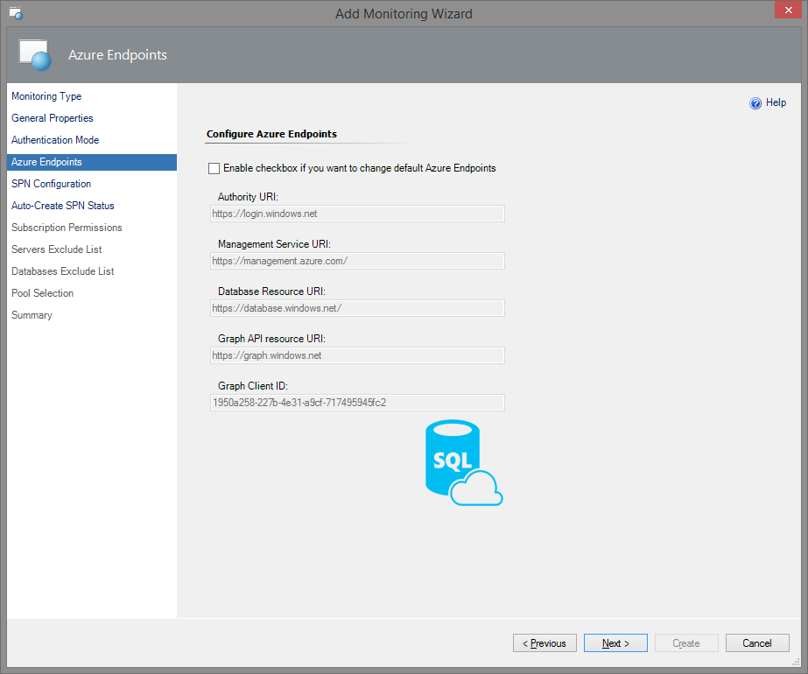
If you need to change the default Azure Endpoints, check the corresponding box. At that, the values in the fields will become editable.
The endpoints used for creating Azure Service Principal are as follows:
- Authority URI: https://login.windows.net
- Management Service URI: https://management.azure.com/
- Database Resource URI: https://database.windows.net/
- Graph API Resource URI: https://graph.windows.net
Note: The https://management.azure.com/ endpoint is also used for Azure SQL REST API. In this case, Firewall port 443 should be used. Nevertheless, according to Ports beyond 1433 for ADO.NET 4.5 article, Firewall port 1433 is to be used.
In SPN Configuration window, you can select between three options: Auto-Create SPN, Use Existing Run As Profile, and Enter SPN Manually.

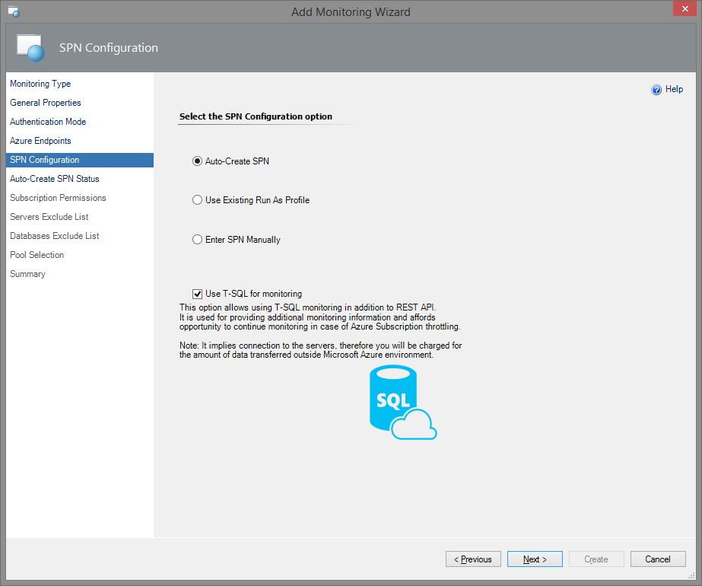
Auto-Create SPN: Azure SQL MP Library creates a new Azure Service Principal Name automatically (using Azure REST API - see Azure REST API Reference article). Then, a new Run As Account will be created with this SPN.
Enter SPN Manually: You have your own SPN (e.g. configured by PowerShell) and enter it manually; then, a new Run As Account will be created with this SPN credentials.
Use Existing Run As Profile: You have already had configured a Run As Profile with appropriate SPN credentials.
Therefore, the concepts are the same; the difference is in the input ways only.
Note: If you want to use T-SQL for monitoring, make sure that the corresponding box is checked in this window (this box is checked by default).
If you select Auto-Create SPN option, Microsoft Azure sign-in window will be displayed upon clicking Next button. In this window, fill in your work, school or personal Microsoft account credentials and click Sign in button.

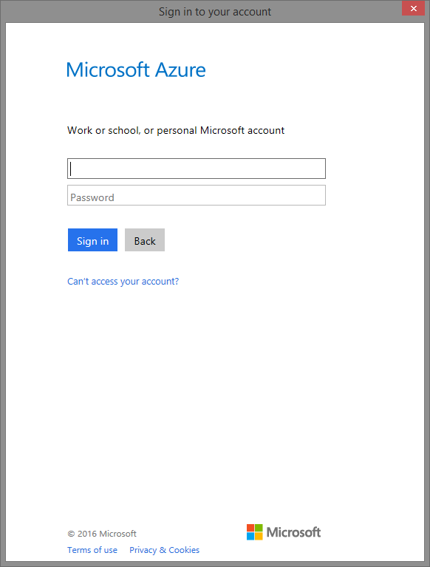
Note: You may receive Internet security alerts on this step. To solve this issue, go to Security section of the Internet Properties and lower the security level for the Internet zone.
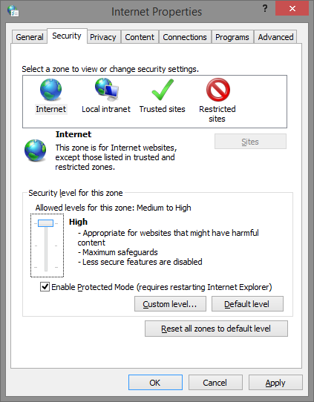
Upon successful creation of the application, the corresponding authentication data will be displayed in Auto-Create SPN Status window.
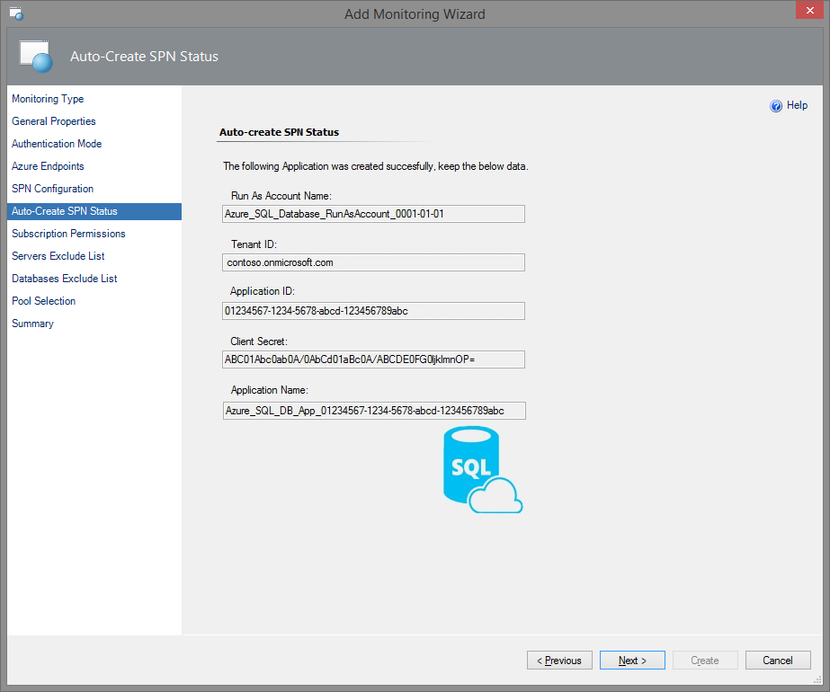
Important: it is strongly recommended to save this data for further usage!
In Subscription Permissions window, select Azure Subscriptions in which you want to add the created Azure Service Principal.

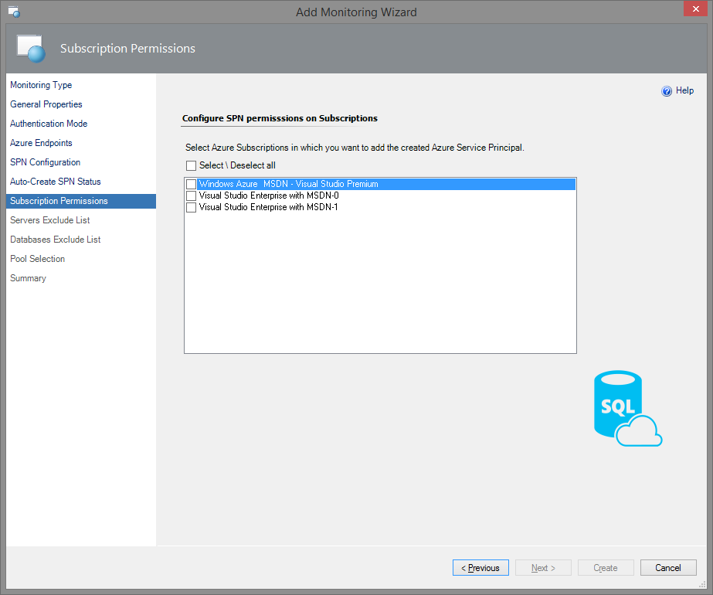
If you want to use an existing Run As profile, you should select the corresponding option in SPN Configuration window.
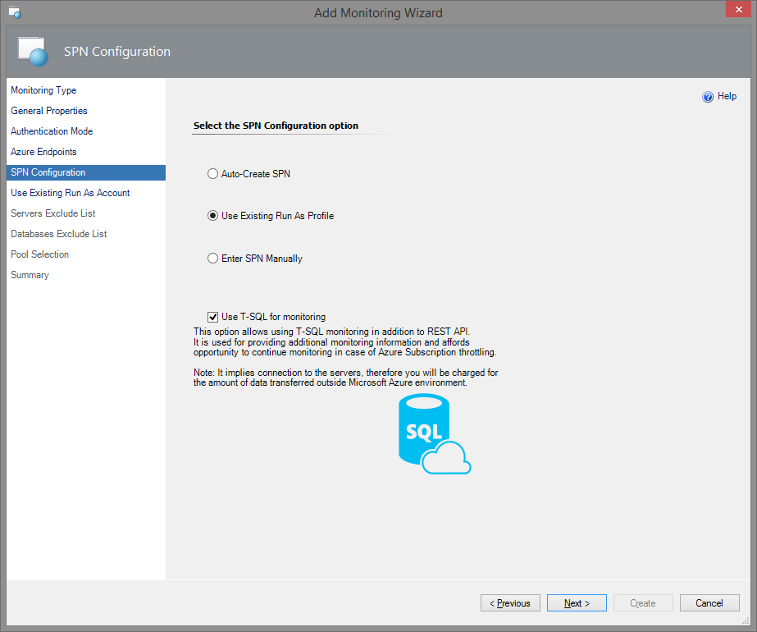
In this case, upon clicking Next button, Use Existing Run As Account window will be displayed.

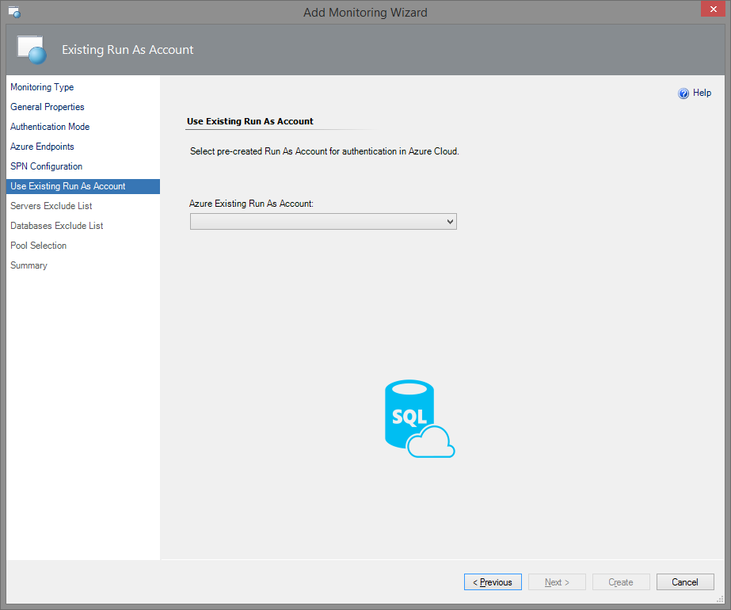
In this window, select an existing Run As Account associated with Azure Service Principal in the drop-down menu. This Run As Account will be used for authentication in Azure Cloud.
If you already have an SPN and want to use it for creation of the Run As Account, you should select the corresponding option in SPN Configuration window.
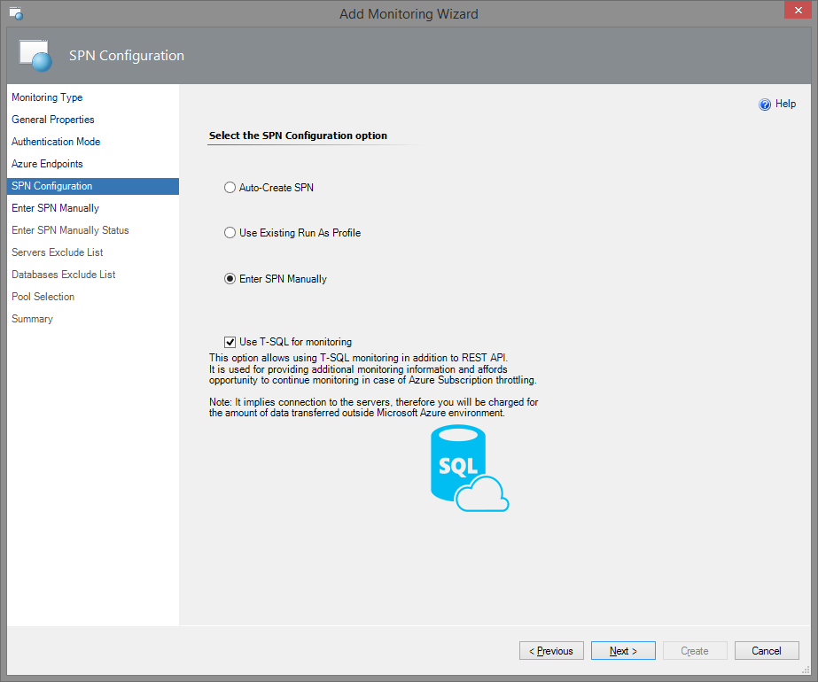
In this case, upon clicking Next button, Enter SPN Manually window will be displayed.
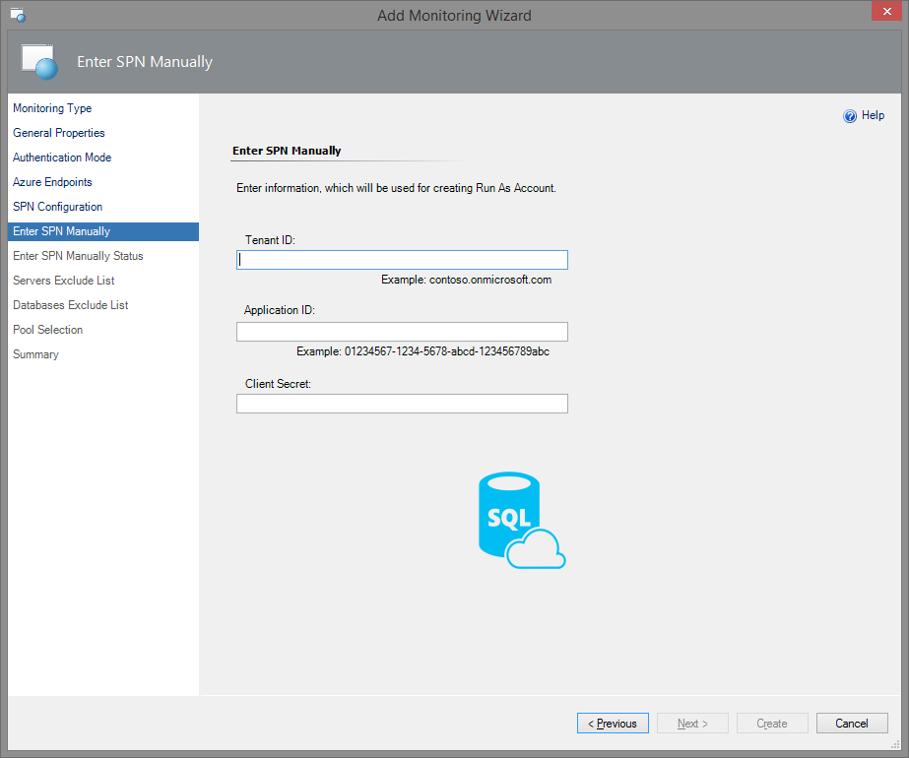
In this window, enter your SPN information in the corresponding fields. This information will be used to create a Run As Account for authentication in Azure Cloud.
Note: If necessary, you can easily create and configure a new Azure Active Directory Application and Service Principal Name by means of Azure PowerShell. Please review the corresponding article to obtain all the necessary information.
In the next two windows of the Wizard, you should configure Server Exclude List and Database Exclude List.
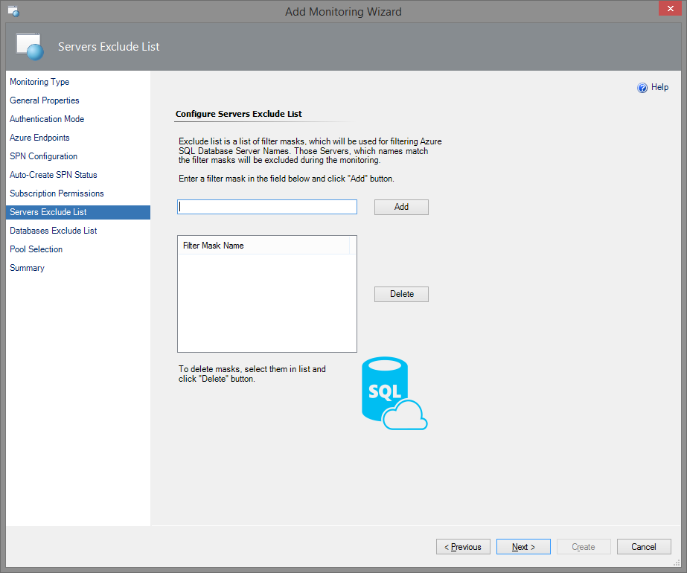
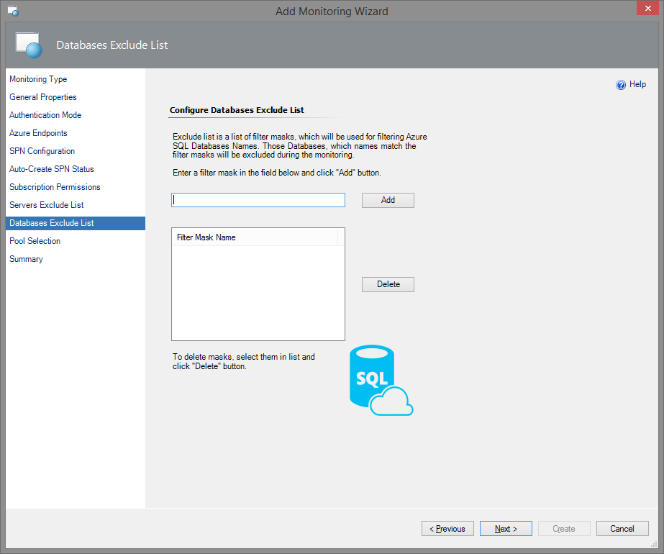
Note: the following Azure Portal specifics must be taken into consideration:
- A server name can contain only lowercase letters, numbers, and '-' character, but cannot start from or end with \-\ character or contain more than 63 characters.
- A database name cannot end with '.' or ' ' characters, contain '<,>,*,%,&,:,\,/,?' or control characters, and can't have more than 128 characters.
Note: Server Exclude List filter mask ignores whitespaces.
To add a mask, which will be used for filtering Azure SQL Databases Names, enter a filter mask in the field below and click Add button. You can also delete the previously added masks by selecting them in the list and clicking Delete button.
In the next window, you should select a Management Server Pool to communicate with Microsoft Azure SQL Database Cloud Service and retrieve the monitoring status and instrumentation. Select the pool from the corresponding drop-down list and click Next button.
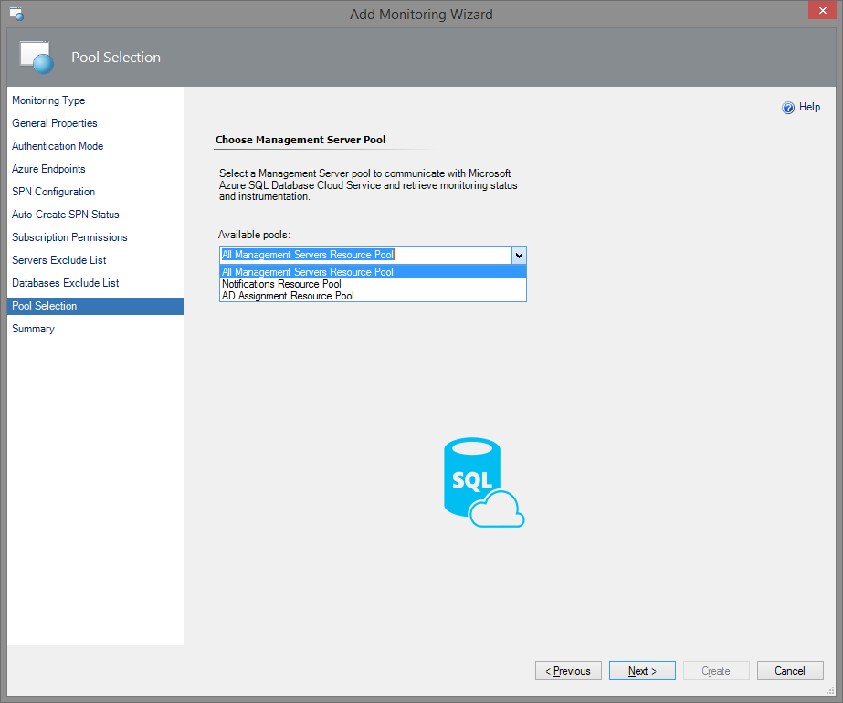
To complete the monitoring configuration, check the applied settings and click Create button on in the Summary window of the Wizard.
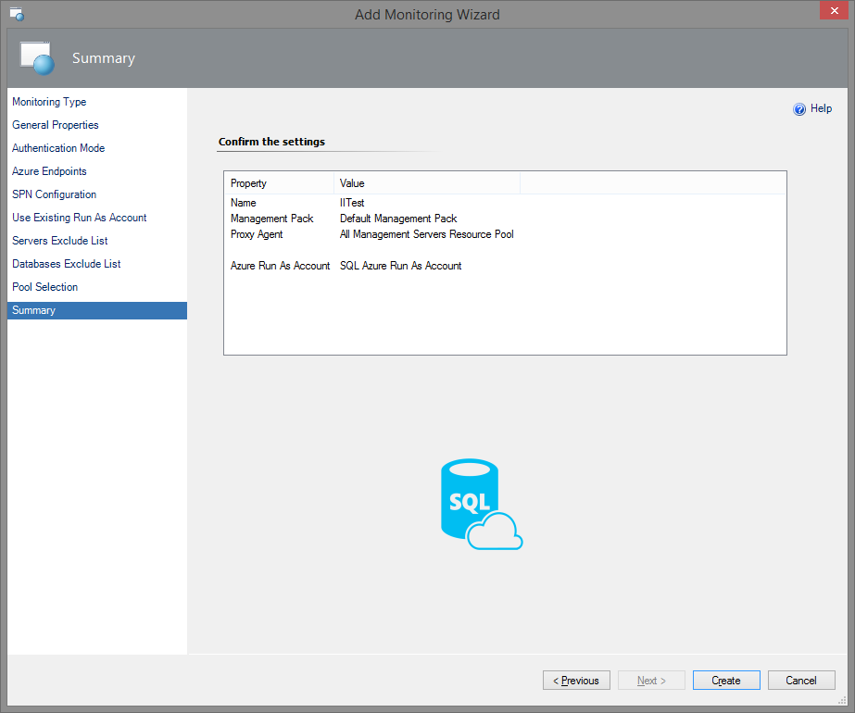

Azure SQL Server Credentials Authentication Mode
If you select Azure Server Credentials authentication mode, choose the corresponding option in Authentication Mode window.
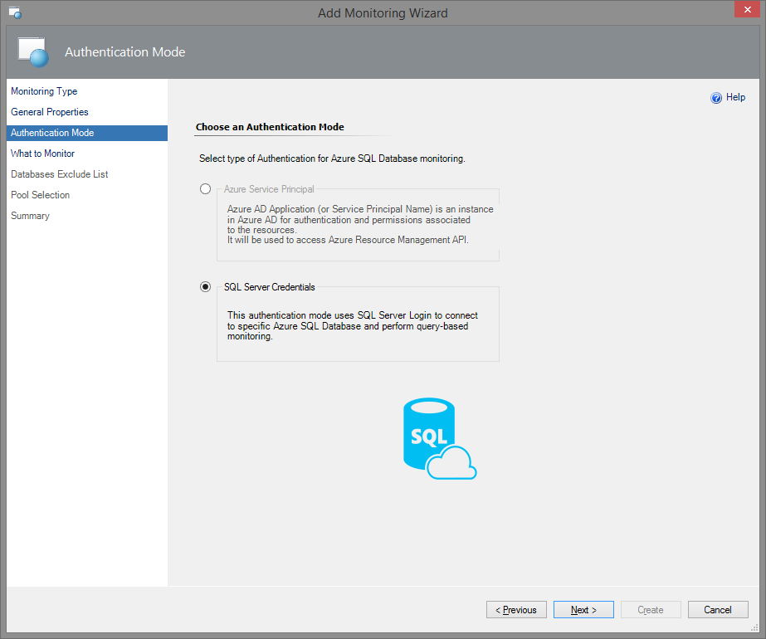
Upon clicking Next button, What to Monitor window will be displayed.
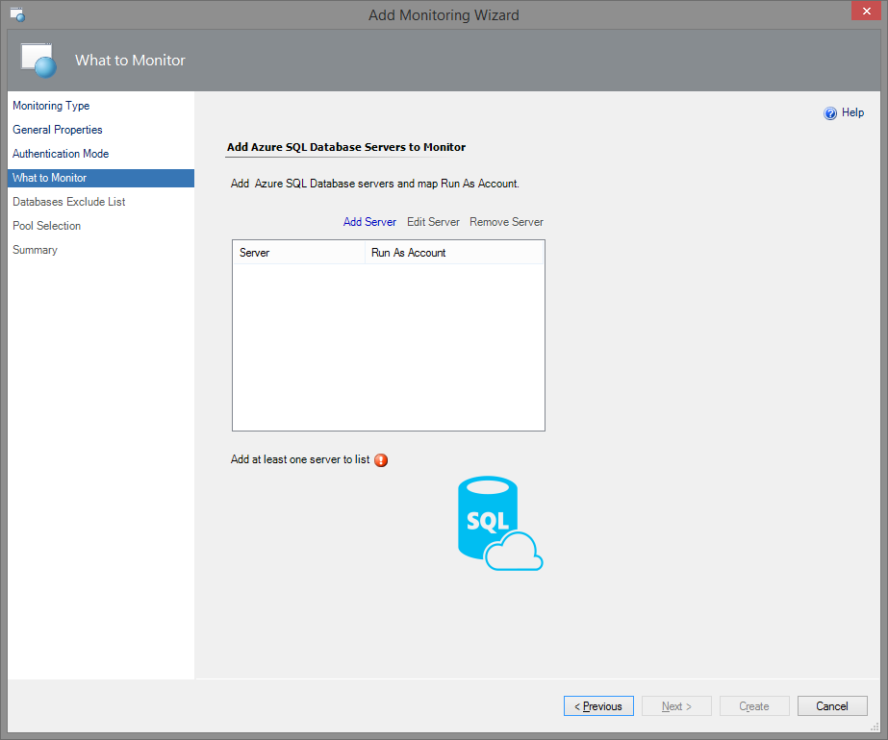
In this window, add Azure SQL Database servers you want to monitor and map the corresponding Run As Account associated with SQL Server Credentials. On this step, you can add, edit and remove the servers. To add a server, click the corresponding button. As a result, Server Configuration window will be displayed.
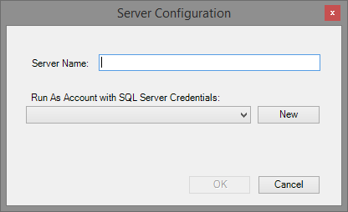
Fill in the server name, select Run As Account with SQL Server credentials and click OK button.
Note: If necessary, you can create a new Run As Account by clicking New button.
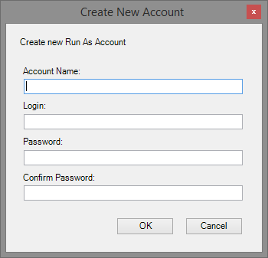
In the corresponding window, enter your new Run As Account name and credentials of the SQL server you want to monitor.
Note: If you need to create a new SQL Server authentication login, the corresponding article to obtain all the necessary information.
The rest configuration steps are the same as in the section above.

Create a New Management Pack for Customizations
The Microsoft Azure SQL Server Monitoring management pack is sealed, so it is not possible to change any of the original settings in the management pack file. However, it is possible to create customization, such as overrides or new monitoring objects, and save them to a different management pack. By default, the Operations Console saves all customizations to the default management pack. As a best practice, instead change the default and save the customizations in separate management packs for each sealed management pack you want to customize.
Creating a new management pack for storing overrides has the following advantages:
- It simplifies the process of exporting customizations that were created in your test and pre-production environments to your production environment. For example, instead of exporting the default management pack that contains customizations from multiple management packs, you can export just the management pack that contains customizations of a single management pack.
- It allows you to delete the original management pack without first needing to delete the default management pack. A management pack that contains customizations is dependent on the original management pack. This dependency requires you to delete the management pack with customizations before you can delete the original management pack. If all of your customizations are saved to the default management pack, you must delete the default management pack before you can delete an original management pack.
- It is easier to track and update customizations to individual management packs.
For more information about sealed and unsealed management packs, see Management Pack Formats article. For more information about management pack customizations and the default management pack, see About Management Packs article.
To Create a New Management Pack for Customizations
1. Open the Operations Console, and then click the Administration button.
2. Right-click Management Packs, and then click Create New Management Pack.
3. Enter a name (for example, “Microsoft Azure SQL Database Customizations”), and click Next.
4. Click Create.

Customize Microsoft Azure SQL Database Management Pack
See Disabled Monitors section for a list of disabled monitors you can enable to generate alerts when performance collection numbers exceed the specific thresholds.
To avoid unnecessary alerts, when you enable the monitors disabled by default, be sure to adjust the thresholds of those monitors to values, which make sense for your databases.

Security Considerations

Run As Accounts
For each set of unique credentials used to monitor Microsoft Azure SQL Database cloud services, create a separate simple or basic authentication Run As account.
For more information about Run As accounts, see Create Microsoft Azure SQL Database Run As Accounts section above.

Low-Privilege Configuration
Since Microsoft Azure SQL Database service evolving very fast – some of the permissions required for monitoring may change over time; thus it is recommended to use Administrator account.
The following steps will allow you to setup a low-privilege account to monitor the service:
- Connect to the master database and create server-level credentials for low-privilege monitoring user by means of the following query:
CREATE LOGIN MonitoringUser WITH PASSWORD = <password>

- Connect to master database and map server-level login to the database user by executing the following query:
CREATE USER MonitoringUser FOR LOGIN MonitoringUser WITH DEFAULT_SCHEMA = sys

- In every user database (excluding master members), map server-level login to the database user and grant it VIEW DATABASE STATE permission by executing the following command:
CREATE USER MonitoringUser FOR LOGIN MonitoringUser WITH DEFAULT_SCHEMA = sys
GO
GRANT VIEW DATABASE STATE TO MonitoringUser

Use this MonitoringUser in Microsoft Azure SQL Database Run As Account.
Important! If you are using Custom User Query Monitoring, you must grant all required permissions to this account as well. Custom query monitors will be using these credentials to execute all queries.

Performance and Billing Considerations
This management pack retrieves data from Microsoft Azure SQL Database, which means you will be charged for the amount of data transfer outside the Microsoft Azure environment. Although management pack queries designed to execute fast and retrieve small amount of data, it is recommended to keep monitoring and discovery intervals as high as possible to reduce load and amount of data transferred.
If you are not interested in one or few metrics collected by the management pack – consider disabling them.

Understand Microsoft Azure SQL Database Management Pack

Classes and Inheritance Diagram

This diagram shows the classes used or defined in the management pack. The green classes are provided by the System Center Operations Manager Infrastructure. The white classes are defined by the Microsoft Azure SQL Database Monitoring management pack. The grey classes are created dynamically by the Add Monitoring Wizard for Microsoft Azure SQL Database.
Note: SQL Azure Federation and Federation member workflows are considered to be deprecated within this management pack.

Class Relationships

This diagram shows hosting and containment relationships defined in the Microsoft Azure SQL Database Monitoring management pack.
Note: SQL Azure Federation and Federation member workflows are considered to be deprecated within this management pack.

Objects the Management Pack Discovers
After using the Add Monitoring Wizard for Microsoft Azure SQL Database (as described in Microsoft Azure SQL Database Add Monitoring Wizard section) to discover Microsoft Azure SQL Database cloud service, the management pack will automatically discover all databases hosted in that cloud service.
Object types discovered by the management pack are described in the following table:
Object type | Discovered Automatically
Microsoft Azure SQL Database Cloud Service | No, use the Add Monitoring Wizard
Microsoft Azure SQL Database User Database | Yes

How Health Rolls Up
The following diagram shows how health rolls up across the classes defined by the management pack.
The management pack rolls up availability and performance health. The management pack does not define any configuration or security monitors, thus no rollups are defined in the management pack. If you want to extend the monitoring with custom configuration and/or security monitoring, you must manually add such rollups.
Note: SQL Azure Federation and Federation member workflows are considered to be deprecated within this management pack.

Key Monitoring Scenarios
Microsoft Azure SQL Database Management Pack includes a number of key monitoring scenarios that can be configured as described below. Detailed information about each specific monitor can be found in Appendix: Management Pack Objects and Workflows.
Note
The list is not intended to be a complete manifest of the management pack functionality.

Service Availability Monitoring
There is a monitor that tracks the availability of discovered Microsoft Azure SQL Database cloud services:
- State changes of the master database
This monitor is not considered noisy, and does not require any special configuration.

Service Performance Monitoring
Currently, there is a single server performance monitor, which detects when the number of databases per server exceeds a specified threshold. By default, this monitor goes into warning state when 120 or more databases are created per server, and goes into critical state when 135 or more databases are created per server. In some situations, these default values are not appropriate. For example, an application may be designed to use all 150 databases for Microsoft Azure SQL Database cloud service. When the default values would create noise, the monitor should be disabled, or the thresholds should be overridden, depending on the situation.
Note that database performance monitors roll up to service performance monitoring, which can affect the health state of the service.

Service Performance Collection
Currently, there is a single rule, which collects the number of databases hosted in each discovered Microsoft Azure SQL Database cloud service.

Database Availability Monitoring
There is a monitor that tracks the availability of the discovered databases:
- State changes of the database
This monitor is not considered noisy, and does not require any special configuration.

Database Performance Monitoring
There are several monitors, which detect when resource consumption has exceeded a predefined limit. Almost all of these monitors are disabled by default, with the exception of the database free space monitor. To use these disabled monitors create an override, which adjusts the thresholds of the monitor to values appropriate for the database applications and then enable the monitor.
The database performance monitors detect excessive:
- Storage space consumed by each database
- Resources consumed by database sessions
- Resources consumed by database transactions

Database Performance Collection
There are several rules, which collect performance information about each discovered database. These rules collect information about:
- Network usage
- The amount of resources consumed by database sessions
- The amount of resources consumed by database transactions
- Disk space consumed by each database

Custom User Query Monitoring
In addition to standard health and performance monitoring of the Microsoft Azure SQL Database cloud service, you can define custom SQL queries to be executed. This allows you to monitor your application-specific health.
Management pack supports two and three states query-based monitors.
Before using custom query monitors, make sure that credentials used for monitoring has all required permissions to execute the queries (see Create Microsoft Azure SQL Database Run As Accounts section for more details).

Two-State Query Monitor
To add a new two-state custom query monitor, perform the following steps:
- In SCOM Console, navigate to Authoring | Management Pack Objects, right-click Monitors and select Create a Monitor | Unit Monitor…

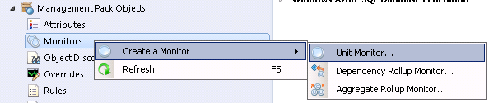

- On the Monitor Type page, select Microsoft Azure SQL Database | User-defined SQL Query Two State Monitor. Select destination management pack and click Next.
If you want to create a custom query monitor for a specific Microsoft Azure SQL Database cloud service, then you must select a management pack with the template used to monitor this service. If you want to add query to all Microsoft Azure SQL Database services, you can store the monitor in any management pack.
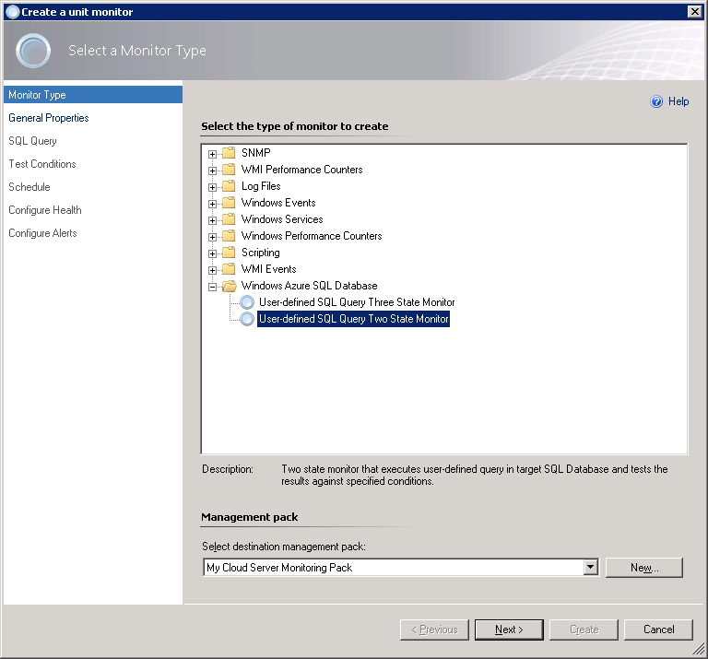

- On the General page, provide monitor Name, optional Description, select Monitor target and Parent monitor. Click Next.
If you selected to save your new monitor in the management pack containing one or more Microsoft Azure SQL Database templates, then you will be able to pick one of Microsoft Azure SQL Database services, monitored by the templates in this management pack. Otherwise, only base Microsoft Azure SQL Database Cloud Service will be available as a target. Selecting Microsoft Azure SQL Database Cloud Server means all cloud services you monitor will be executing your query.
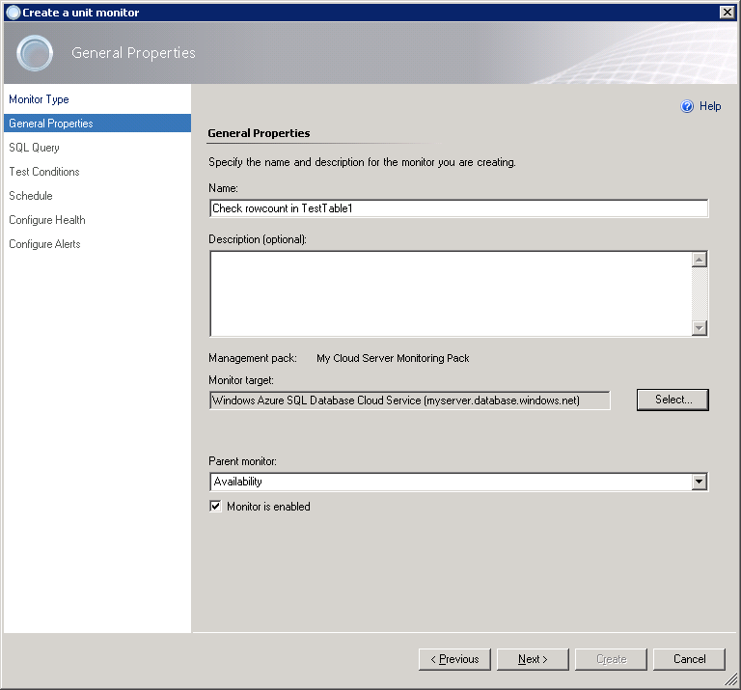

- On the SQL Query page, you must provide Database name, Query text and Timeout (in seconds).
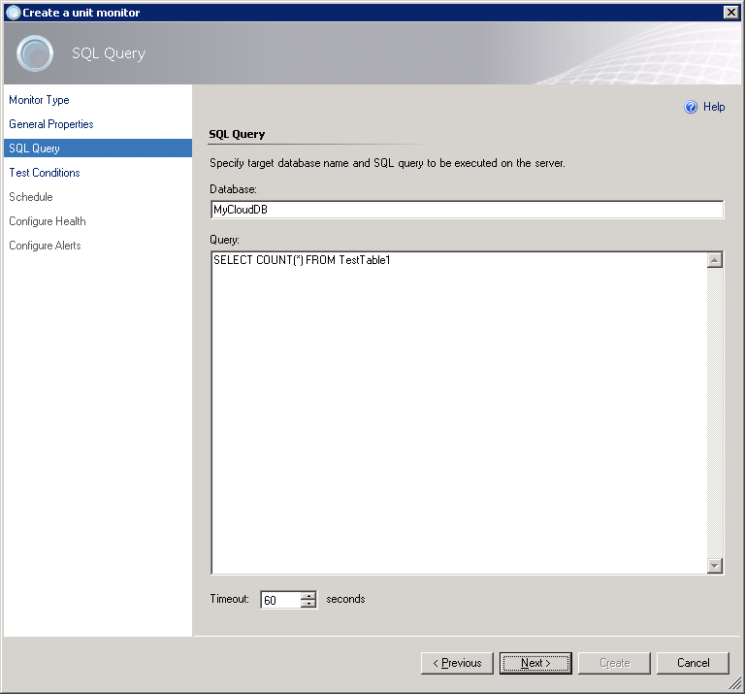

- On the Test Conditions page, add one or more Test conditions to verify query results.
To add a new condition, click Add and pick one of the available conditions from the drop-down list:
- Empty Result Set
Checks if the specified result set returned by the query is empty.
- Not Empty Result Set
Checks if the specified result set returned by the query is not empty.
- Scalar Value
Checks scalar value in the specified cell of the result set. Only equal comparison is available at this moment; if you need complex logic, you must cover that by the query.
- Execution Time
Checks execution duration of the query.
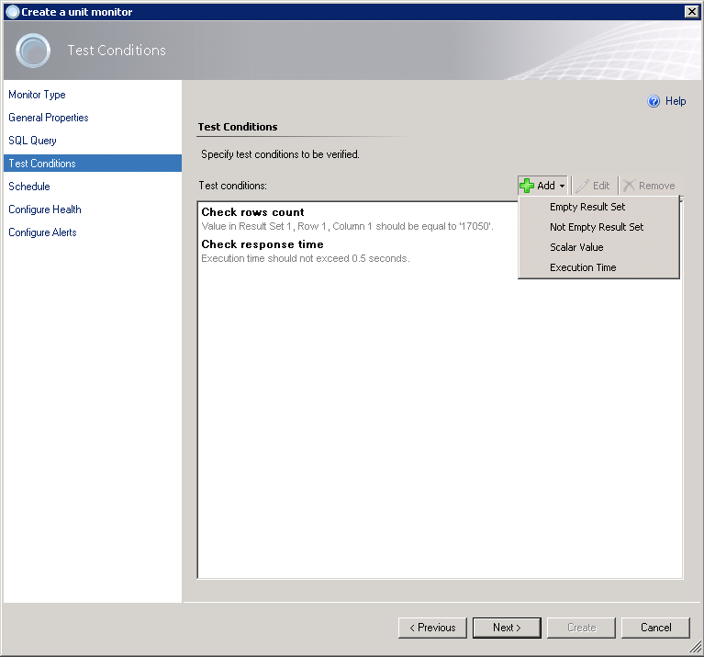

- When you are adding the condition, you must specify Friendly name and the entire configuration required for specific check to be performed.
We will be using Scalar Value condition to verify rows count in the TestTable1.
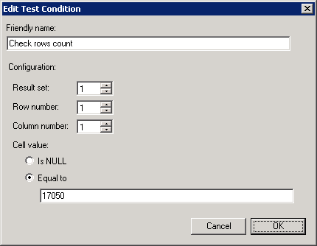

- You can have more than one condition. It is useful to add Execution Time condition to all tests to check how your Microsoft Azure SQL Database service is performing.

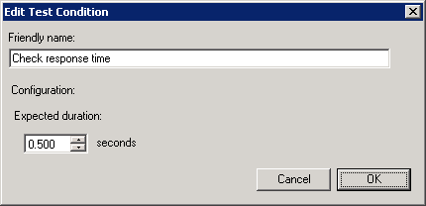

- When you are done adding all required conditions, click Next.
- On the Schedule page, you must specify how frequently your query will be executed.
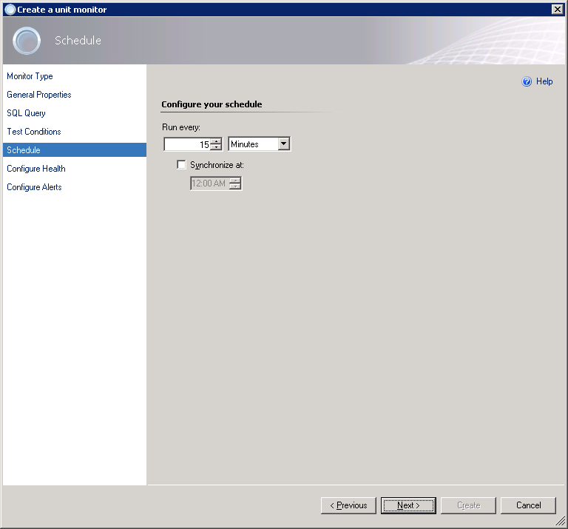

- On the Configure Health page, you can select what health state should be generated by the monitor.
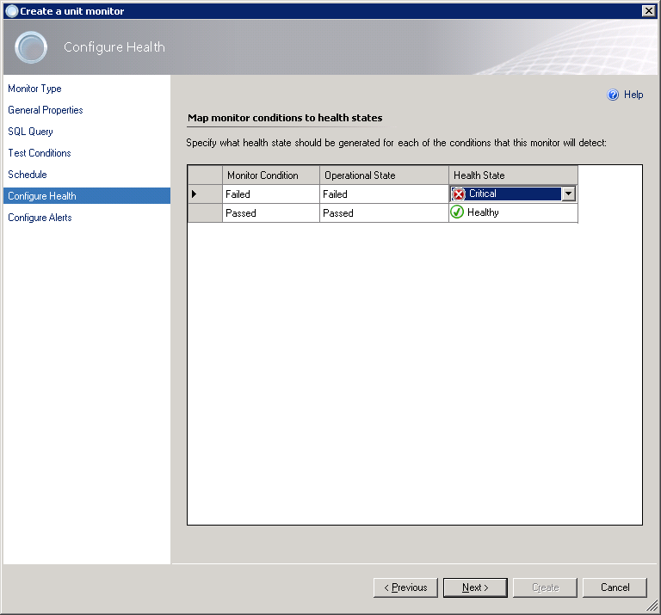

- On the Configure Alerts page, you can setup an alert name and description to be shown in case if one or more test conditions fails.
Use $Data/Context/Property[@Name=’Message’]$ placeholder to show list of failed tests in the alert description.
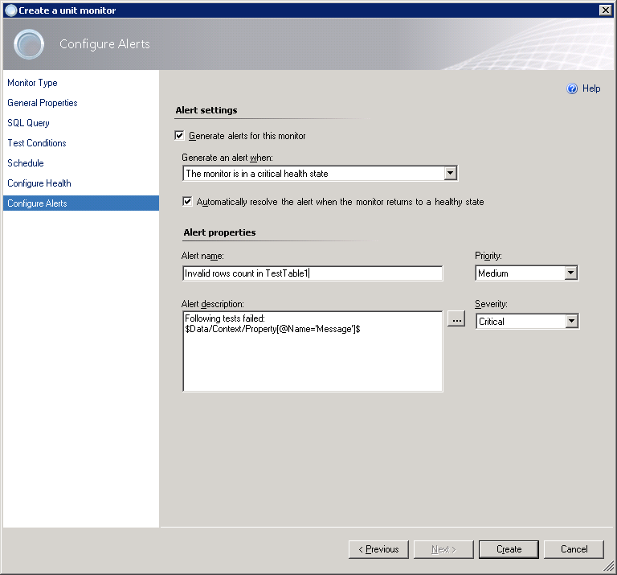
Click Create when you finish.
Now, you can see the new monitor available for your service:
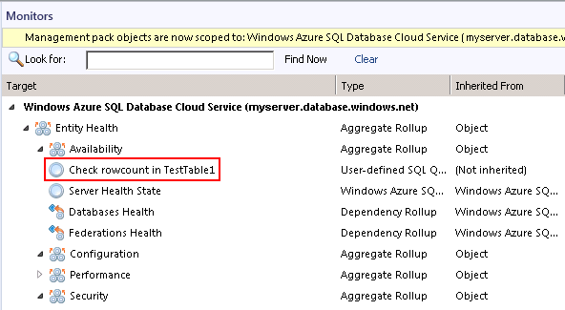

Three-State Query Monitor
Adding a new three-state query monitor is similar to two-state monitor. The main difference is that you must specify Warning and Critical sets of conditions.
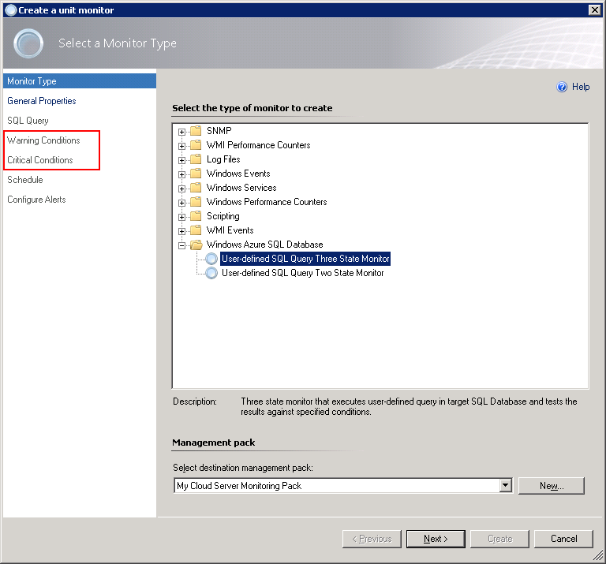
Critical conditions will be verified first. If one or more critical conditions fail – the monitor will switch to critical state and warning conditions will not be verified.
For more information on how to setup query and conditions, see Two-State Query Monitor section above.

View Information in the Operations Console
You can observe a high-level view of object types in your Microsoft Azure SQL Database service.
A view can contain a lengthy list of objects. To find a specific object or group of objects, you can use Scope, Search, and Find buttons on the Operations Manager toolbar. For more information, see Finding Data and Objects in the Operations Manager Consoles article.
The following views are provided with Microsoft Azure SQL Database management pack and are available under Microsoft Azure SQL Database node in the Monitoring pane of the Operations Console:
- Active Alerts
- Watcher Nodes
  - Databases
    - Database State
  - Performance
    - All Performance Data
    - Database Network
    - Database Sessions
    - Database Space
    - Database Transactions
  - Servers
    - Server State
    - Servers Diagram

Database Views
The following table describes views reflecting the databases’ health.
View Path | Description
Databases\Database State | Displays a list of the monitored databases and their current states. Double-click the health state icon for a database to launch a Health Explorer window for that database to locate the monitors, which are affecting the health state of the server, and investigate any issues.  The Detail View pane displays the properties of the database selected above.
Performance\Database Network | The Legend pane displays a list of network-related counters for every monitored database.  The chart illustrates the information selected in the Legend pane.
Performance\Database Sessions | The Legend pane displays a list of database sessions related counters for every monitored database.  The chart illustrates the information selected in the Legend pane.
Performance\Database Space | The Legend pane displays a list of disk space related counters for every monitored database.  The chart illustrates the information selected in the Legend pane.
Performance\Database Transactions | The Legend pane displays a list of database transactions related counters for every monitored database.  The chart illustrates the information selected in the Legend pane.

Server Views
Following table describes views reflecting cloud services health.
View Path | Description
Servers\Server State | Displays a list of monitored cloud services and their current states. Double-click the health state icon for a service to launch Health Explorer window for that service to locate the monitors, which are affecting the health state, and investigate any issues.  The Detail View pane displays the properties of the server selected above.
Servers\Servers Diagram | Displays structured picture of all monitored cloud services with hosted databases.  Expand required cloud service node to drill down to hosted objects.

Appendix: Known Issues and Troubleshooting
“The item you are trying to delete cannot be deleted because another object references it” error appears when trying to remove the template
Problem: When you are trying to remove a monitoring template, the following message is displayed:
“The item you are trying to delete cannot be deleted because another object references it…”
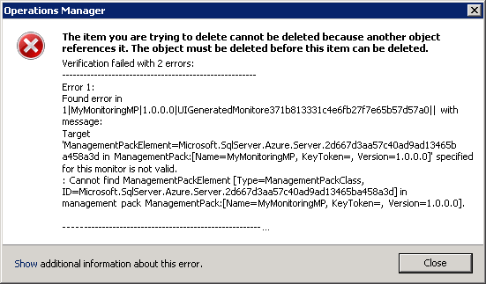
This is a known SCOM issue. Since SCOM does not support cascade delete for templates, you must manually remove all monitors targeting the server defined by the template, before you will be able to remove the template itself.
Resolution: In SCOM Console, navigate to Authoring | Management Pack Objects | Monitors, scope the list to the server, defined by the template you want to delete and remove all custom monitors.
Some Elastic Pools may not be discovered
Problem: Elastic Pools that do not contain any databases are not discovered.
Resolution: No resolution.
Error messages are received when Azure SQL Server is discovered by means of several templates simultaneously
Problem: If several Microsoft Azure SQL Database templates with different user rights are used simultaneously to discover same Azure SQL Servers, error events (ID 6302) appear in the Operations Manager Event Viewer.
Resolution: Make sure that each Azure SQL Server is discovered by means of a single template only.
Rules and monitors may provide incorrect data if default interval override values are changed
Problem: If the value of Interval (seconds) overridable parameter is set lower than the default value, rules and monitors may provide incorrect data.
Resolution: Make sure that Interval (seconds) overridable parameter is set no lower than the default value.
T-SQL monitoring does not work if REST connection is unavailable
Problem: T-SQL monitoring does not work if REST connection is unavailable, only space-monitoring rules are working correctly.
Resolution: No resolution.
Server exclude list option may work incorrectly
Problem: Server exclude list may behave incorrectly: the set masks may disappear from the list, and some performance may be received from the servers that should have been excluded.
Resolution: No resolution.
Some performance collection rules fail to collect data when REST+T-SQL is enabled
Problem: The following rules fail to collect performance data when REST+T-SQL is enabled:
- Azure SQL DB: DB Sessions Count
- Azure SQL DB: DB Sessions Average Memory Consumption (MB)
- Azure SQL DB: DB Sessions Rows Returned
- Azure SQL DB: DB Sessions Total CPU Time (ms)
- Azure SQL DB: DB Sessions Total Memory Consumption (MB)
- Azure SQL DB: DB Sessions Total Read/Write Operations
- Azure SQL DB: DB Transactions Locks Count
- Azure SQL DB: DB Transactions Max Log Usage (MB)
- Azure SQL DB: DB Transactions Max Running Time (minutes)
At that, the event log stays clear of the corresponding errors or warnings.
Resolution: perform the following requests on the SQL Server:
CREATE USER [ApplicationName] FROM EXTERNAL PROVIDER;
GRANT VIEW DATABASE STATE TO [ApplicationName] - at User database
exec sp_addrolemember 'dbmanager', 'ApplicationName' - at Master database
"Use T-SQL for monitoring" checkbox configuration cannot be saved
Problem: After creating Azure SQL Database Monitoring template using "Azure Service Principal" Authentication Mode and "Use Existing Run As Profile" SPN Configuration, "Use T-SQL for monitoring" checkbox remains enabled regardless of the user choice.
Resolution: No resolution.
The monitored objects become unavailable if management server is changed in the resource pool
Problem: The monitored objects become unavailable (turn grey) in the Operations Manager if management server is changed in the resource pool. An alert with the following description is displayed in the SCOM log: “The pool member no longer owns any managed objects assigned to the pool because half or fewer members of the pool have acknowledged the most recent lease request. The pool member has unloaded the workflows for managed objects it previously owned.”
Resolution: Wait until the objects are processed on the new management server.
Azure Portal may stop retrieving results in responses to Azure REST API requests from some performance rules
Problem: In case of great number of databases (about 1000 databases), Azure Portal may stop retrieving results in responses to Azure REST API requests from some performance rules. There errors in such responses are as follows:
HTTP/1.1 504 Gateway Timeout
.....
Connection: close
Content-Length: 141
{"error":{"code":"GatewayTimeout","message":"The gateway did not receive a response from 'Microsoft.Sql' within the specified time period."}}
Resolution: No resolution.
SQL connection to the Azure SQL Databases may fail if the number of databases is great
Problem: If the number of databases is great (over 2000 databases), SQL connection to the Azure SQL Databases may fail with the following exceptions:
- A connection was successfully established with the server, but then an error occurred during the pre-login handshake.
- Connection Timeout Expired. The timeout period elapsed while attempting to consume the pre-login handshake acknowledgement. This could be because the pre-login handshake failed or the server was unable to respond back in time.
- A network-related or instance-specific error occurred while establishing a connection to SQL Server. The server was not found or was not accessible. Verify that the instance name is correct and the SQL Server is configured to allow remote connections.
As a result, Database Connection Availability monitor changes its state from “Healthy” to “Warning”. It may also affect workflows with T-SQL query datasources due to connection loss.
Resolution: No resolution.
"Azure SQL DB: DB Failed Connections Count" rule shows different data for REST and T-SQL monitoring types
Problem: Data provided by "Azure SQL DB: DB Failed Connections Count" rule differs for REST and T-SQL monitoring types: the data provided for T-SQL lacks "Azure SQL DB: DB Blocked by Firewall Count" information, while it is provided for REST.
Resolution: No resolution.

Appendix: Disabled Monitors
Most of the database performance monitors are disabled by default, because the appropriate thresholds need to be determined based on the database applications being monitored. If this functionality is required for proper monitoring of the database applications, then perform the following:
- Determine the correct threshold values based on the expected usage patterns or observed resource consumption.
- Override one or more of these monitors to adjust the thresholds and enable them.
Disabled monitors are as follows:
- Monitors Count of connections blocked by the Firewall
- Monitors Count of Failed Connection
- Sessions
  - Sessions Count
  - Sessions Average Memory
  - Sessions Rows Returned
  - Sessions Total CPU Time
  - Sessions Total I/O
  - Sessions Total Memory
- Transactions
  - Transaction Locks Count
  - Transaction Log Space Used
  - Transaction Execution Time

Details about these monitors can be found in Appendix: Management Pack Objects and Workflows below.

Appendix: Management Pack Objects and Workflows
[Deprecated] Microsoft Azure SQL Database Federation
[Deprecated] SQL Database Federation hosted in Microsoft Azure.
[Deprecated] Microsoft Azure SQL Database Federation - Discoveries
Microsoft Azure SQL Database Federations Discovery
This workflow discovers federations hosted in Microsoft Azure SQL Database Cloud Server.
Name | Description | Default value
Enabled | Enables or disables the workflow. | No
Interval (seconds) | The recurring interval of time in seconds in which to run the workflow. | 14400
Synchronization Time | The synchronization time specified by using a 24-hour format. May be omitted.
Timeout (seconds) | Specifies the time the workflow is allowed to run before being closed and marked as failed. | 600

[Deprecated] Microsoft Azure SQL Database Federation - Dependency (rollup) monitors
Members Health
Rolls up all federation members availability monitors to the server.

Members Performance
Rolls up all federation members performance monitors to the server.

[Deprecated] Microsoft Azure SQL Database Federation Member
[Deprecated] SQL Database Federation Member hosted in Microsoft Azure.
[Deprecated] Microsoft Azure SQL Database Federation Member - Discoveries
Microsoft Azure SQL Database Federations Discovery
This workflow discovers federations hosted in Microsoft Azure SQL Database Cloud Server.
Name | Description | Default value
Enabled | Enables or disables the workflow. | No
Interval (seconds) | The recurring interval of time in seconds in which to run the workflow. | 14400
Synchronization Time | The synchronization time specified by using a 24-hour format. May be omitted.
Timeout (seconds) | Specifies the time the workflow is allowed to run before being closed and marked as failed. | 600

Azure SQL Cloud Services
A group containing Azure SQL Cloud Services
Azure SQL Cloud Services - Discoveries
Azure SQL Cloud Services Group Discovery
This workflow populates Azure SQL Database Cloud Service for Azure SQL Cloud Services Group.

Azure SQL Database Cloud Services
A group containing Azure SQL Database Cloud Services
Azure SQL Database Cloud Services - Discoveries
Azure SQL Database Cloud Services Group Discovery
This workflow populates Azure SQL Database for Azure SQL Database Cloud Services Group.

Microsoft Azure SQL Database
SQL Database hosted in Microsoft Azure.
Microsoft Azure SQL Database - Discoveries
Microsoft Azure SQL User Databases Discovery
This workflow discovers user databases hosted in Microsoft Azure SQL Database Cloud Service.
Name | Description | Default value
Enabled | Enables or disables the workflow. | Yes
Interval (seconds) | The recurring interval of time in seconds in which to run the workflow. | 14400
Monitoring Mode | Defines monitoring mode. | $Target/Property[Type="Microsoft.SqlServer.Azure.Server"]/MonitoringMode$
Request timeout (seconds) | Gets or sets the timespan to wait before the request times out. | 60
Synchronization Time | The synchronization time specified by using a 24-hour format. May be omitted.
Timeout (seconds) | Specifies the time the workflow is allowed to run before being closed and marked as failed. | 600
Timeout for database connection (seconds) | A period in which the workflow must establish connection to the database. | 30

Microsoft Azure SQL Database - Rules (non-alerting)
[Deprecated] Azure SQL DB: DB Internal Network Egress (KB)
This rule collects internal network egress for Microsoft Azure SQL Database in kilobytes. This rule has been deprecated in Azure SQL Database V12 logical server.
Note that in order to prevent incorrect data collection, the value of Interval (seconds) overridable parameter should not be set lower than the default value.
Name | Description | Default value
Enabled | Enables or disables the workflow. | No
Generate Alerts | Defines whether the workflow generates an Alert. | No
Interval (seconds) | The recurring interval of time in seconds in which to run the workflow. | 900
Synchronization Time | The synchronization time specified by using a 24-hour format. May be omitted.
Timeout (seconds) | Specifies the time the workflow is allowed to run before being closed and marked as failed. | 600

[Deprecated] Azure SQL DB: DB Internal Network Ingress (KB)
This rule collects internal network ingress for Microsoft Azure SQL Database in kilobytes. This rule has been deprecated in Azure SQL Database V12 logical server.
Note that in order to prevent incorrect data collection, the value of Interval (seconds) overridable parameter should not be set lower than the default value.
Name | Description | Default value
Enabled | Enables or disables the workflow. | No
Generate Alerts | Defines whether the workflow generates an Alert. | No
Interval (seconds) | The recurring interval of time in seconds in which to run the workflow. | 900
Synchronization Time | The synchronization time specified by using a 24-hour format. May be omitted.
Timeout (seconds) | Specifies the time the workflow is allowed to run before being closed and marked as failed. | 600

[Deprecated] Azure SQL DB: DB External Network Egress (KB)
This rule collects external network egress for Microsoft Azure SQL Database in kilobytes. This rule has been deprecated in Azure SQL Database V12 logical server.
Note that in order to prevent incorrect data collection, the value of Interval (seconds) overridable parameter should not be set lower than the default value.
Name | Description | Default value
Enabled | Enables or disables the workflow. | No
Generate Alerts | Defines whether the workflow generates an Alert. | No
Interval (seconds) | The recurring interval of time in seconds in which to run the workflow. | 900
Synchronization Time | The synchronization time specified by using a 24-hour format. May be omitted.
Timeout (seconds) | Specifies the time the workflow is allowed to run before being closed and marked as failed. | 600

[Deprecated] Azure SQL DB: DB External Network Ingress (KB)
This rule collects external network ingress for Microsoft Azure SQL Database in kilobytes. This rule has been deprecated in Azure SQL Database V12 logical server.
Note that in order to prevent incorrect data collection, the value of Interval (seconds) overridable parameter should not be set lower than the default value.
Name | Description | Default value
Enabled | Enables or disables the workflow. | No
Generate Alerts | Defines whether the workflow generates an Alert. | No
Interval (seconds) | The recurring interval of time in seconds in which to run the workflow. | 900
Synchronization Time | The synchronization time specified by using a 24-hour format. May be omitted.
Timeout (seconds) | Specifies the time the workflow is allowed to run before being closed and marked as failed. | 600

Microsoft Azure SQL Database Cloud Service
A cloud service hosting SQL Databases.
Microsoft Azure SQL Database Cloud Service - Discoveries
Microsoft Azure SQL Database Cloud Service Advanced Properties Discovery
This workflow discovers advanced properties of Microsoft Azure SQL Database Cloud Service.
Name | Description | Default value
Enabled | Enables or disables the workflow. | Yes
Interval (seconds) | The recurring interval of time in seconds in which to run the workflow. | 14400
Monitoring Mode | Defines monitoring mode. | $Target/Property[Type="Microsoft.SqlServer.Azure.Server"]/MonitoringMode$
Synchronization Time | The synchronization time specified by using a 24-hour format. May be omitted.
Timeout (seconds) | Specifies the time the workflow is allowed to run before being closed and marked as failed. | 600
Timeout for database connection (seconds) | A period in which the workflow must establish connection to the database. | 30

Microsoft Azure SQL Database Cloud Service - Unit monitors
Server Connection Availability
This monitor checks the availability of connection to the server.
Note that in order to prevent incorrect data collection, the value of Interval (seconds) overridable parameter should not be set lower than the default value.
Name | Description | Default value
Enabled | Enables or disables the workflow. | Yes
Generate Alerts | Defines whether the workflow generates an Alert. | True
Interval (seconds) | The recurring interval of time in seconds in which to run the workflow. | 900
Request timeout (seconds) | Gets or sets the timespan to wait before the request times out. | 60
Synchronization Time | The synchronization time specified by using a 24-hour format. May be omitted.
Timeout (seconds) | Specifies the time the workflow is allowed to run before being closed and marked as failed. | 600
Timeout for database connection (seconds) | A period in which the workflow must establish connection to the database. | 30

Percent of Allocated DTUs
Monitors the number of database transaction units (DTUs) allocated by the server in relation to the limit per server.
Note that in order to prevent incorrect data collection, the value of Interval (seconds) overridable parameter should not be set lower than the default value.
Name | Description | Default value
Enabled | Enables or disables the workflow. | Yes
Generate Alerts | Defines whether the workflow generates an Alert. | True
Critical Threshold | The monitor will change the state to Critical if the value drops below this threshold. | 90
Interval (seconds) | The recurring interval of time in seconds in which to run the workflow. | 900
Monitoring Mode | Defines monitoring mode. | $Target/Property[Type="Microsoft.SqlServer.Azure.Server"]/MonitoringMode$
Request timeout (seconds) | Gets or sets the timespan to wait before the request times out. | 60
Synchronization Time | The synchronization time specified by using a 24-hour format. May be omitted.
Timeout (seconds) | Specifies the time the workflow is allowed to run before being closed and marked as failed. | 600
Timeout for database connection (seconds) | A period in which the workflow must establish connection to the database. | 30
Warning Threshold | The monitor will change the state to Warning if the value drops below this threshold. | 85

Maximum Number of Databases
Monitors the number of extant databases in relation to the limit per server.
Note that in order to prevent incorrect data collection, the value of Interval (seconds) overridable parameter should not be set lower than the default value.
Name | Description | Default value
Enabled | Enables or disables the workflow. | Yes
Generate Alerts | Defines whether the workflow generates an Alert. | True
Critical Threshold | The monitor will change the state to Critical if the value drops below this threshold. | 135
Interval (seconds) | The recurring interval of time in seconds in which to run the workflow. | 900
Monitoring Mode | Defines monitoring mode. | $Target/Property[Type="Microsoft.SqlServer.Azure.Server"]/MonitoringMode$
Request timeout (seconds) | Gets or sets the timespan to wait before the request times out. | 60
Synchronization Time | The synchronization time specified by using a 24-hour format. May be omitted.
Timeout (seconds) | Specifies the time the workflow is allowed to run before being closed and marked as failed. | 600
Timeout for database connection (seconds) | A period in which the workflow must establish connection to the database. | 30
Warning Threshold | The monitor will change the state to Warning if the value drops below this threshold. | 120

Server Health State
This monitor checks the health state of the “master” database.
Note that in order to prevent incorrect data collection, the value of Interval (seconds) overridable parameter should not be set lower than the default value.
Name | Description | Default value
Enabled | Enables or disables the workflow. | Yes
Generate Alerts | Defines whether the workflow generates an Alert. | True
Interval (seconds) | The recurring interval of time in seconds in which to run the workflow. | 900
Monitoring Mode | Defines monitoring mode. | $Target/Property[Type="Microsoft.SqlServer.Azure.Server"]/MonitoringMode$
Request timeout (seconds) | Gets or sets the timespan to wait before the request times out. | 60
Synchronization Time | The synchronization time specified by using a 24-hour format. May be omitted.
Timeout (seconds) | Specifies the time the workflow is allowed to run before being closed and marked as failed. | 600
Timeout for database connection (seconds) | A period in which the workflow must establish connection to the database. | 30

Microsoft Azure SQL Database Cloud Service - Dependency (rollup) monitors
Elastic Pools Performance
Rolls up all elastic pools performance monitors to the server.

Federations Health
Rolls up all federations availability monitors to the server.

Federations Performance
Rolls up all federations’ performance monitors to the server.

Databases Health
Rolls up all user databases availability monitors to the server.

Databases Performance
Rolls up all user databases performance monitors to the server.

Elastic Pools Health
Rolls up all elastic pools availability monitors to the server.

Microsoft Azure SQL Database Cloud Service - Rules (non-alerting)
Azure SQL DB: Server DTU Used Count
This rule collects the number of DTUs allocated by Microsoft Azure SQL Database Cloud Service.
Note that in order to prevent incorrect data collection, the value of Interval (seconds) overridable parameter should not be set lower than the default value.
Name | Description | Default value
Enabled | Enables or disables the workflow. | Yes
Generate Alerts | Defines whether the workflow generates an Alert. | No
Interval (seconds) | The recurring interval of time in seconds in which to run the workflow. | 900
Maximum Sample Separation |  | 4
Monitoring Mode | Defines monitoring mode. | $Target/Property[Type="Microsoft.SqlServer.Azure.Server"]/MonitoringMode$
Optimization Tolerance |  | 1
Request timeout (seconds) | Gets or sets the timespan to wait before the request times out. | 60
Synchronization Time | The synchronization time specified by using a 24-hour format. May be omitted.
Timeout (seconds) | Specifies the time the workflow is allowed to run before being closed and marked as failed. | 600
Timeout for database connection (seconds) | A period in which the workflow must establish connection to the database. | 30

Azure SQL DB: Server DTU Percentage
This rule collects DTUs allocated by Microsoft Azure SQL Database Cloud Service in percentage terms.
Note that in order to prevent incorrect data collection, the value of Interval (seconds) overridable parameter should not be set lower than the default value.
Name | Description | Default value
Enabled | Enables or disables the workflow. | Yes
Generate Alerts | Defines whether the workflow generates an Alert. | No
Interval (seconds) | The recurring interval of time in seconds in which to run the workflow. | 900
Maximum Sample Separation |  | 4
Monitoring Mode | Defines monitoring mode. | $Target/Property[Type="Microsoft.SqlServer.Azure.Server"]/MonitoringMode$
Optimization Tolerance |  | 1
Request timeout (seconds) | Gets or sets the timespan to wait before the request times out. | 60
Synchronization Time | The synchronization time specified by using a 24-hour format. May be omitted.
Timeout (seconds) | Specifies the time the workflow is allowed to run before being closed and marked as failed. | 600
Timeout for database connection (seconds) | A period in which the workflow must establish connection to the database. | 30

Azure SQL DB: Server Databases Count
This rule collects the number of Microsoft Azure SQL Database hosted in Microsoft Azure SQL Database Cloud Service.
Note that in order to prevent incorrect data collection, the value of Interval (seconds) overridable parameter should not be set lower than the default value.
Name | Description | Default value
Enabled | Enables or disables the workflow. | Yes
Generate Alerts | Defines whether the workflow generates an Alert. | No
Interval (seconds) | The recurring interval of time in seconds in which to run the workflow. | 900
Monitoring Mode | Defines monitoring mode. | $Target/Property[Type="Microsoft.SqlServer.Azure.Server"]/MonitoringMode$
Request timeout (seconds) | Gets or sets the timespan to wait before the request times out. | 60
Synchronization Time | The synchronization time specified by using a 24-hour format. May be omitted.
Timeout (seconds) | Specifies the time the workflow is allowed to run before being closed and marked as failed. | 600
Timeout for database connection (seconds) | A period in which the workflow must establish connection to the database. | 30

Azure SQL DB: Server DTU Limit Count
This rule collects the number of DTUs Microsoft Azure SQL Database Cloud Service can allocate before reaching limit.
Note that in order to prevent incorrect data collection, the value of Interval (seconds) overridable parameter should not be set lower than the default value.
Name | Description | Default value
Enabled | Enables or disables the workflow. | Yes
Generate Alerts | Defines whether the workflow generates an Alert. | No
Interval (seconds) | The recurring interval of time in seconds in which to run the workflow. | 900
Maximum Sample Separation |  | 4
Monitoring Mode | Defines monitoring mode. | $Target/Property[Type="Microsoft.SqlServer.Azure.Server"]/MonitoringMode$
Optimization Tolerance |  | 1
Request timeout (seconds) | Gets or sets the timespan to wait before the request times out. | 60
Synchronization Time | The synchronization time specified by using a 24-hour format. May be omitted.
Timeout (seconds) | Specifies the time the workflow is allowed to run before being closed and marked as failed. | 600
Timeout for database connection (seconds) | A period in which the workflow must establish connection to the database. | 30

Microsoft Azure SQL Database Cloud Service - Console Tasks
Launch Microsoft Azure SQL Database Management Portal
Browses to Microsoft Azure SQL Database Management Portal for performing server and database administration tasks.

Microsoft Azure SQL Database Cloud Services
A group containing Microsoft Azure SQL Database Cloud Services.
Microsoft Azure SQL Database Cloud Services - Discoveries
Microsoft Azure SQL Database Cloud Services Group Discovery
This workflow populates the Microsoft Azure SQL Database Cloud Services group with SQL Database Cloud Services.

Microsoft Azure SQL Database Components Group
A group containing all components related to Microsoft Azure SQL Databases.
Microsoft Azure SQL Database Components Group - Discoveries
Microsoft Azure SQL Database Components Group Discovery
This workflow populates the Microsoft Azure SQL Database Components Group with related entities.

Microsoft Azure SQL Database Event Log Collection Target
This object is used to collect module errors from event logs of management servers that have Microsoft Azure SQL Database components.
Microsoft Azure SQL Database Event Log Collection Target - Discoveries
Microsoft Azure SQL Database Event Log Collection Target Management Service Discovery
This discovery rule discovers an event log collection target for a Microsoft Azure SQL Database. This object is used to collect module errors from event logs of management server computers.
Name | Description | Default value
Enabled | Enables or disables the workflow. | Yes
Discover | This parameter is used to decide whether the Event Log Collection Target should be added to or removed from the Management Service. By default, inclusion into the Microsoft Azure SQL Monitoring Management Service Pool Group is the criteria. | true
Interval (seconds) | The recurring interval of time in seconds in which to run the workflow. | 14400
Synchronization Time | The synchronization time specified by using a 24-hour format. May be omitted.

Microsoft Azure SQL Database Event Log Collection Target - Rules (alerting)
Microsoft Azure SQL Database .Net Framework Rule
This rule provides Microsoft Azure SQL Database Management Pack workflows .Net Framework version check.
Note that in order to prevent incorrect data collection, the value of Interval (seconds) overridable parameter should not be set lower than the default value.
Name | Description | Default value
Enabled | Enables or disables the workflow. | Yes
Generate Alerts | Defines whether the workflow generates an Alert. | Yes
Interval (seconds) | The recurring interval of time in seconds in which to run the workflow. | 900
Priority | Defines Alert Priority. | 2
Severity | Defines Alert Severity. | 2
Synchronization Time | The synchronization time specified by using a 24-hour format. May be omitted.
Timeout (seconds) | Specifies the time the workflow is allowed to run before being closed and marked as failed. | 600

Microsoft Azure SQL Database Management Pack Self-Monitoring
This rule provides Microsoft Azure SQL Database Management Pack workflows self-monitoring for critical issues.
Name | Description | Default value
Enabled | Enables or disables the workflow. | Yes
Generate Alerts | Defines whether the workflow generates an Alert. | Yes
Priority | Defines Alert Priority. | 2
Severity | Defines Alert Severity. | 2

Microsoft Azure SQL Database Management Pack Self-Monitoring (Non-Critical)
This rule provides Microsoft Azure SQL Database Management Pack workflows self-monitoring for non-critical issues.
Name | Description | Default value
Enabled | Enables or disables the workflow. | Yes
Generate Alerts | Defines whether the workflow generates an Alert. | Yes
Priority | Defines Alert Priority. | 1
Severity | Defines Alert Severity. | 1

Microsoft Azure SQL Database in Elastic Database Pool
SQL Database hosted in Microsoft Azure Elastic Database Pool.
Microsoft Azure SQL Database in Elastic Database Pool - Discoveries
Microsoft Azure SQL User Databases Discovery
This workflow discovers user databases hosted in Microsoft Azure SQL Database Cloud Service.
Name | Description | Default value
Enabled | Enables or disables the workflow. | Yes
Interval (seconds) | The recurring interval of time in seconds in which to run the workflow. | 14400
Monitoring Mode | Defines monitoring mode. | $Target/Property[Type="Microsoft.SqlServer.Azure.Server"]/MonitoringMode$
Request timeout (seconds) | Gets or sets the timespan to wait before the request times out. | 60
Synchronization Time | The synchronization time specified by using a 24-hour format. May be omitted.
Timeout (seconds) | Specifies the time the workflow is allowed to run before being closed and marked as failed. | 600
Timeout for database connection (seconds) | A period in which the workflow must establish connection to the database. | 30

Microsoft Azure SQL Database Replication
SQL Database geo-replicated across different servers in Microsoft Azure.
Microsoft Azure SQL Database Replication - Discoveries
Microsoft Azure SQL Database Replications Discovery
This workflow discovers Geo-Replications of databases hosted in Microsoft Azure SQL Database Cloud Service.
Name | Description | Default value
Enabled | Enables or disables the workflow. | Yes
Interval (seconds) | The recurring interval of time in seconds in which to run the workflow. | 14400
Monitoring Mode | Defines monitoring mode. | $Target/Host/Property[Type="Microsoft.SqlServer.Azure.Server"]/MonitoringMode$
Request timeout (seconds) | Gets or sets the timespan to wait before the request times out. | 60
Synchronization Time | The synchronization time specified by using a 24-hour format. May be omitted.
Timeout (seconds) | Specifies the time the workflow is allowed to run before being closed and marked as failed. | 13800
Timeout for database connection (seconds) | A period in which the workflow must establish connection to the database. | 30

Microsoft Azure SQL Database Replication - Dependency (rollup) monitors
Databases Health
Rolls up all user databases in geo-replication availability monitors to the replication database.

Databases Performance
Rolls up all user databases in geo-replication performance monitors to the replication database.

Microsoft Azure SQL Elastic Database Pool
SQL Elastic Database Pool hosted in Microsoft Azure.
Microsoft Azure SQL Elastic Database Pool - Discoveries
Microsoft Azure SQL Elastic Pool Discovery
Discovers Elastic Database Pools for the server.
Name | Description | Default value
Enabled | Enables or disables the workflow. | Yes
Interval (seconds) | The recurring interval of time in seconds in which to run the workflow. | 7200
Request timeout (seconds) | Gets or sets the timespan to wait before the request times out. | 60
Synchronization Time | The synchronization time specified by using a 24-hour format. May be omitted.
Timeout (seconds) | Specifies the time the workflow is allowed to run before being closed and marked as failed. | 600
Timeout for database connection (seconds) | A period in which the workflow must establish connection to the database. | 30

Microsoft Azure SQL Elastic Database Pool - Unit monitors
Maximum Number of Databases
Monitors the number of extant databases in relation to the limit per pool.
Note that in order to prevent incorrect data collection, the value of Interval (seconds) overridable parameter should not be set lower than the default value.
Name | Description | Default value
Enabled | Enables or disables the workflow. | Yes
Generate Alerts | Defines whether the workflow generates an Alert. | True
Critical Threshold | The monitor will change the state to Critical if the value drops below this threshold. | 400
Interval (seconds) | The recurring interval of time in seconds in which to run the workflow. | 900
Monitoring Mode | Defines monitoring mode. | $Target/Host/Property[Type="Microsoft.SqlServer.Azure.Server"]/MonitoringMode$
Request timeout (seconds) | Gets or sets the timespan to wait before the request times out. | 60
Synchronization Time | The synchronization time specified by using a 24-hour format. May be omitted.
Timeout (seconds) | Specifies the time the workflow is allowed to run before being closed and marked as failed. | 600
Timeout for database connection (seconds) | A period in which the workflow must establish connection to the database. | 30
Warning Threshold | The monitor will change the state to Warning if the value drops below this threshold. | 200

Data IO Percentage
Monitors the Data IO Utilization consumed by all databases in Elastic Pool.
Note that in order to prevent incorrect data collection, the value of Interval (seconds) overridable parameter should not be set lower than the default value.
Name | Description | Default value
Enabled | Enables or disables the workflow. | Yes
Generate Alerts | Defines whether the workflow generates an Alert. | True
Critical Threshold | The monitor will change the state to Critical if the value drops below this threshold. | 95
Interval (seconds) | The recurring interval of time in seconds in which to run the workflow. | 900
Monitoring Mode | Defines monitoring mode. | $Target/Host/Property[Type="Microsoft.SqlServer.Azure.Server"]/MonitoringMode$
Request timeout (seconds) | Gets or sets the timespan to wait before the request times out. | 60
Synchronization Time | The synchronization time specified by using a 24-hour format. May be omitted.
Timeout (seconds) | Specifies the time the workflow is allowed to run before being closed and marked as failed. | 600
Timeout for database connection (seconds) | A period in which the workflow must establish connection to the database. | 30
Warning Threshold | The monitor will change the state to Warning if the value drops below this threshold. | 90

Log IO Percentage
Monitors the Log Write Utilization consumed by all databases in Elastic Pool.
Note that in order to prevent incorrect data collection, the value of Interval (seconds) overridable parameter should not be set lower than the default value.
Name | Description | Default value
Enabled | Enables or disables the workflow. | Yes
Generate Alerts | Defines whether the workflow generates an Alert. | True
Critical Threshold | The monitor will change the state to Critical if the value drops below this threshold. | 85
Interval (seconds) | The recurring interval of time in seconds in which to run the workflow. | 900
Monitoring Mode | Defines monitoring mode. | $Target/Host/Property[Type="Microsoft.SqlServer.Azure.Server"]/MonitoringMode$
Request timeout (seconds) | Gets or sets the timespan to wait before the request times out. | 60
Synchronization Time | The synchronization time specified by using a 24-hour format. May be omitted.
Timeout (seconds) | Specifies the time the workflow is allowed to run before being closed and marked as failed. | 600
Timeout for database connection (seconds) | A period in which the workflow must establish connection to the database. | 30
Warning Threshold | The monitor will change the state to Warning if the value drops below this threshold. | 75

CPU Utilization (%)
Monitors the total CPU Utilization consumed by all databases in Elastic Pool.
Note that in order to prevent incorrect data collection, the value of Interval (seconds) overridable parameter should not be set lower than the default value.
Name | Description | Default value
Enabled | Enables or disables the workflow. | Yes
Generate Alerts | Defines whether the workflow generates an Alert. | True
Critical Threshold | The monitor will change the state to Critical if the value drops below this threshold. | 80
Interval (seconds) | The recurring interval of time in seconds in which to run the workflow. | 900
Monitoring Mode | Defines monitoring mode. | $Target/Host/Property[Type="Microsoft.SqlServer.Azure.Server"]/MonitoringMode$
Request timeout (seconds) | Gets or sets the timespan to wait before the request times out. | 60
Synchronization Time | The synchronization time specified by using a 24-hour format. May be omitted.
Timeout (seconds) | Specifies the time the workflow is allowed to run before being closed and marked as failed. | 600
Timeout for database connection (seconds) | A period in which the workflow must establish connection to the database. | 30
Warning Threshold | The monitor will change the state to Warning if the value drops below this threshold. | 75

Sessions Percentage
Monitors the Sessions Utilization consumed by all databases in Elastic Pool.
Note that in order to prevent incorrect data collection, the value of Interval (seconds) overridable parameter should not be set lower than the default value.
Name | Description | Default value
Enabled | Enables or disables the workflow. | Yes
Generate Alerts | Defines whether the workflow generates an Alert. | True
Critical Threshold | The monitor will change the state to Critical if the value drops below this threshold. | 90
Interval (seconds) | The recurring interval of time in seconds in which to run the workflow. | 900
Monitoring Mode | Defines monitoring mode. | $Target/Host/Property[Type="Microsoft.SqlServer.Azure.Server"]/MonitoringMode$
Request timeout (seconds) | Gets or sets the timespan to wait before the request times out. | 60
Synchronization Time | The synchronization time specified by using a 24-hour format. May be omitted.
Timeout (seconds) | Specifies the time the workflow is allowed to run before being closed and marked as failed. | 600
Timeout for database connection (seconds) | A period in which the workflow must establish connection to the database. | 30
Warning Threshold | The monitor will change the state to Warning if the value drops below this threshold. | 80

Workers Percentage
Monitors the Storage Utilization consumed by all databases in Elastic Pool.
Note that in order to prevent incorrect data collection, the value of Interval (seconds) overridable parameter should not be set lower than the default value.
Name | Description | Default value
Enabled | Enables or disables the workflow. | Yes
Generate Alerts | Defines whether the workflow generates an Alert. | True
Critical Threshold | The monitor will change the state to Critical if the value drops below this threshold. | 85
Interval (seconds) | The recurring interval of time in seconds in which to run the workflow. | 900
Monitoring Mode | Defines monitoring mode. | $Target/Host/Property[Type="Microsoft.SqlServer.Azure.Server"]/MonitoringMode$
Request timeout (seconds) | Gets or sets the timespan to wait before the request times out. | 60
Synchronization Time | The synchronization time specified by using a 24-hour format. May be omitted.
Timeout (seconds) | Specifies the time the workflow is allowed to run before being closed and marked as failed. | 600
Timeout for database connection (seconds) | A period in which the workflow must establish connection to the database. | 30
Warning Threshold | The monitor will change the state to Warning if the value drops below this threshold. | 75

Storage Percentage
Monitors the Storage Utilization consumed by all databases in Elastic Pool.
Note that in order to prevent incorrect data collection, the value of Interval (seconds) overridable parameter should not be set lower than the default value.
Name | Description | Default value
Enabled | Enables or disables the workflow. | Yes
Generate Alerts | Defines whether the workflow generates an Alert. | True
Critical Threshold | The monitor will change the state to Critical if the value drops below this threshold. | 90
Interval (seconds) | The recurring interval of time in seconds in which to run the workflow. | 900
Monitoring Mode | Defines monitoring mode. | $Target/Host/Property[Type="Microsoft.SqlServer.Azure.Server"]/MonitoringMode$
Request timeout (seconds) | Gets or sets the timespan to wait before the request times out. | 60
Synchronization Time | The synchronization time specified by using a 24-hour format. May be omitted.
Timeout (seconds) | Specifies the time the workflow is allowed to run before being closed and marked as failed. | 600
Timeout for database connection (seconds) | A period in which the workflow must establish connection to the database. | 30
Warning Threshold | The monitor will change the state to Warning if the value drops below this threshold. | 80

eDTU Percentage
Monitors the eDTU Utilization consumed by all databases in Elastic Pool.
Note that in order to prevent incorrect data collection, the value of Interval (seconds) overridable parameter should not be set lower than the default value.
Name | Description | Default value
Enabled | Enables or disables the workflow. | Yes
Generate Alerts | Defines whether the workflow generates an Alert. | True
Critical Threshold | The monitor will change the state to Critical if the value drops below this threshold. | 85
Interval (seconds) | The recurring interval of time in seconds in which to run the workflow. | 900
Monitoring Mode | Defines monitoring mode. | $Target/Host/Property[Type="Microsoft.SqlServer.Azure.Server"]/MonitoringMode$
Request timeout (seconds) | Gets or sets the timespan to wait before the request times out. | 60
Synchronization Time | The synchronization time specified by using a 24-hour format. May be omitted.
Timeout (seconds) | Specifies the time the workflow is allowed to run before being closed and marked as failed. | 600
Timeout for database connection (seconds) | A period in which the workflow must establish connection to the database. | 30
Warning Threshold | The monitor will change the state to Warning if the value drops below this threshold. | 75

Microsoft Azure SQL Elastic Database Pool - Dependency (rollup) monitors
Databases Health
Rolls up all elastic pool databases availability monitors to the elastic pool.

Databases Performance
Rolls up all elastic pool databases performance monitors to the elastic pool.

Microsoft Azure SQL Elastic Database Pool - Rules (non-alerting)
Azure SQL DB: Elastic Pool eDTU Used
This rule collects the eDTU resources of Microsoft Azure SQL Elastic Database Pool in unit terms.
Note that in order to prevent incorrect data collection, the value of Interval (seconds) overridable parameter should not be set lower than the default value.
Name | Description | Default value
Enabled | Enables or disables the workflow. | Yes
Generate Alerts | Defines whether the workflow generates an Alert. | No
Interval (seconds) | The recurring interval of time in seconds in which to run the workflow. | 900
Monitoring Mode | Defines monitoring mode. | $Target/Host/Property[Type="Microsoft.SqlServer.Azure.Server"]/MonitoringMode$
Request timeout (seconds) | Gets or sets the timespan to wait before the request times out. | 60
Synchronization Time | The synchronization time specified by using a 24-hour format. May be omitted.
Timeout (seconds) | Specifies the time the workflow is allowed to run before being closed and marked as failed. | 600
Timeout for database connection (seconds) | A period in which the workflow must establish connection to the database. | 30

Azure SQL DB: Elastic Pool Log IO Percentage
This rule collects the log write utilization of Microsoft Azure SQL Elastic Database Pool in percentage terms.
Note that in order to prevent incorrect data collection, the value of Interval (seconds) overridable parameter should not be set lower than the default value.
Name | Description | Default value
Enabled | Enables or disables the workflow. | Yes
Generate Alerts | Defines whether the workflow generates an Alert. | No
Interval (seconds) | The recurring interval of time in seconds in which to run the workflow. | 900
Monitoring Mode | Defines monitoring mode. | $Target/Host/Property[Type="Microsoft.SqlServer.Azure.Server"]/MonitoringMode$
Request timeout (seconds) | Gets or sets the timespan to wait before the request times out. | 60
Synchronization Time | The synchronization time specified by using a 24-hour format. May be omitted.
Timeout (seconds) | Specifies the time the workflow is allowed to run before being closed and marked as failed. | 600
Timeout for database connection (seconds) | A period in which the workflow must establish connection to the database. | 30

Azure SQL DB: Elastic Pool CPU Percentage
This rule collects the CPU resources of Microsoft Azure SQL Elastic Database Pool in percentage terms.
Note that in order to prevent incorrect data collection, the value of Interval (seconds) overridable parameter should not be set lower than the default value.
Name | Description | Default value
Enabled | Enables or disables the workflow. | Yes
Generate Alerts | Defines whether the workflow generates an Alert. | No
Interval (seconds) | The recurring interval of time in seconds in which to run the workflow. | 900
Monitoring Mode | Defines monitoring mode. | $Target/Host/Property[Type="Microsoft.SqlServer.Azure.Server"]/MonitoringMode$
Request timeout (seconds) | Gets or sets the timespan to wait before the request times out. | 60
Synchronization Time | The synchronization time specified by using a 24-hour format. May be omitted.
Timeout (seconds) | Specifies the time the workflow is allowed to run before being closed and marked as failed. | 600
Timeout for database connection (seconds) | A period in which the workflow must establish connection to the database. | 30

Azure SQL DB: Elastic Pool Databases Count
This rule collects the number of Microsoft Azure SQL Databases.
Note that in order to prevent incorrect data collection, the value of Interval (seconds) overridable parameter should not be set lower than the default value.
Name | Description | Default value
Enabled | Enables or disables the workflow. | Yes
Generate Alerts | Defines whether the workflow generates an Alert. | No
Interval (seconds) | The recurring interval of time in seconds in which to run the workflow. | 900
Monitoring Mode | Defines monitoring mode. | $Target/Host/Property[Type="Microsoft.SqlServer.Azure.Server"]/MonitoringMode$
Request timeout (seconds) | Gets or sets the timespan to wait before the request times out. | 60
Synchronization Time | The synchronization time specified by using a 24-hour format. May be omitted.
Timeout (seconds) | Specifies the time the workflow is allowed to run before being closed and marked as failed. | 600
Timeout for database connection (seconds) | A period in which the workflow must establish connection to the database. | 30

Azure SQL DB: Elastic Pool Sessions Percentage
This rule collects the sessions’ count of Microsoft Azure SQL Elastic Database Pool in percentage terms per limit.
Note that in order to prevent incorrect data collection, the value of Interval (seconds) overridable parameter should not be set lower than the default value.
Name | Description | Default value
Enabled | Enables or disables the workflow. | Yes
Generate Alerts | Defines whether the workflow generates an Alert. | No
Interval (seconds) | The recurring interval of time in seconds in which to run the workflow. | 900
Monitoring Mode | Defines monitoring mode. | $Target/Host/Property[Type="Microsoft.SqlServer.Azure.Server"]/MonitoringMode$
Request timeout (seconds) | Gets or sets the timespan to wait before the request times out. | 60
Synchronization Time | The synchronization time specified by using a 24-hour format. May be omitted.
Timeout (seconds) | Specifies the time the workflow is allowed to run before being closed and marked as failed. | 600
Timeout for database connection (seconds) | A period in which the workflow must establish connection to the database. | 30

Azure SQL DB: Elastic Pool eDTU Percentage
This rule collects the eDTU resources of Microsoft Azure SQL Elastic Database Pool in percentage terms.
Note that in order to prevent incorrect data collection, the value of Interval (seconds) overridable parameter should not be set lower than the default value.
Name | Description | Default value
Enabled | Enables or disables the workflow. | Yes
Generate Alerts | Defines whether the workflow generates an Alert. | No
Interval (seconds) | The recurring interval of time in seconds in which to run the workflow. | 900
Monitoring Mode | Defines monitoring mode. | $Target/Host/Property[Type="Microsoft.SqlServer.Azure.Server"]/MonitoringMode$
Request timeout (seconds) | Gets or sets the timespan to wait before the request times out. | 60
Synchronization Time | The synchronization time specified by using a 24-hour format. May be omitted.
Timeout (seconds) | Specifies the time the workflow is allowed to run before being closed and marked as failed. | 600
Timeout for database connection (seconds) | A period in which the workflow must establish connection to the database. | 30

Azure SQL DB: Elastic Pool Storage Percentage
This rule collects the storage utilization of Microsoft Azure SQL Elastic Database Pool in percentage terms.
Note that in order to prevent incorrect data collection, the value of Interval (seconds) overridable parameter should not be set lower than the default value.
Name | Description | Default value
Enabled | Enables or disables the workflow. | Yes
Generate Alerts | Defines whether the workflow generates an Alert. | No
Interval (seconds) | The recurring interval of time in seconds in which to run the workflow. | 900
Monitoring Mode | Defines monitoring mode. | $Target/Host/Property[Type="Microsoft.SqlServer.Azure.Server"]/MonitoringMode$
Request timeout (seconds) | Gets or sets the timespan to wait before the request times out. | 60
Synchronization Time | The synchronization time specified by using a 24-hour format. May be omitted.
Timeout (seconds) | Specifies the time the workflow is allowed to run before being closed and marked as failed. | 600
Timeout for database connection (seconds) | A period in which the workflow must establish connection to the database. | 30

Azure SQL DB: Elastic Pool Data IO Percentage
This rule collects the data IO utilization of Microsoft Azure SQL Elastic Database Pool in percentage terms.
Note that in order to prevent incorrect data collection, the value of Interval (seconds) overridable parameter should not be set lower than the default value.
Name | Description | Default value
Enabled | Enables or disables the workflow. | Yes
Generate Alerts | Defines whether the workflow generates an Alert. | No
Interval (seconds) | The recurring interval of time in seconds in which to run the workflow. | 900
Monitoring Mode | Defines monitoring mode. | $Target/Host/Property[Type="Microsoft.SqlServer.Azure.Server"]/MonitoringMode$
Request timeout (seconds) | Gets or sets the timespan to wait before the request times out. | 60
Synchronization Time | The synchronization time specified by using a 24-hour format. May be omitted.
Timeout (seconds) | Specifies the time the workflow is allowed to run before being closed and marked as failed. | 600
Timeout for database connection (seconds) | A period in which the workflow must establish connection to the database. | 30

Azure SQL DB: Elastic Pool Workers Percentage
This rule collects the workers utilization of Microsoft Azure SQL Elastic Database Pool in percentage terms.
Note that in order to prevent incorrect data collection, the value of Interval (seconds) overridable parameter should not be set lower than the default value.
Name | Description | Default value
Enabled | Enables or disables the workflow. | Yes
Generate Alerts | Defines whether the workflow generates an Alert. | No
Interval (seconds) | The recurring interval of time in seconds in which to run the workflow. | 900
Monitoring Mode | Defines monitoring mode. | $Target/Host/Property[Type="Microsoft.SqlServer.Azure.Server"]/MonitoringMode$
Request timeout (seconds) | Gets or sets the timespan to wait before the request times out. | 60
Synchronization Time | The synchronization time specified by using a 24-hour format. May be omitted.
Timeout (seconds) | Specifies the time the workflow is allowed to run before being closed and marked as failed. | 600
Timeout for database connection (seconds) | A period in which the workflow must establish connection to the database. | 30

Microsoft Azure SQL User Database
SQL Azure User Database hosted on SQL Azure Server.
Microsoft Azure SQL User Database - Discoveries
Microsoft Azure SQL User Databases Discovery
This workflow discovers user databases hosted in Microsoft Azure SQL Database Cloud Service.
Name | Description | Default value
Enabled | Enables or disables the workflow. | Yes
Interval (seconds) | The recurring interval of time in seconds in which to run the workflow. | 14400
Monitoring Mode | Defines monitoring mode. | $Target/Property[Type="Microsoft.SqlServer.Azure.Server"]/MonitoringMode$
Request timeout (seconds) | Gets or sets the timespan to wait before the request times out. | 60
Synchronization Time | The synchronization time specified by using a 24-hour format. May be omitted.
Timeout (seconds) | Specifies the time the workflow is allowed to run before being closed and marked as failed. | 600
Timeout for database connection (seconds) | A period in which the workflow must establish connection to the database. | 30

Microsoft Azure SQL User Database - Unit monitors
Workers Percentage
Monitors the total amount of maximum concurrent workers (requests) consumed by all database sessions.
Note that in order to prevent incorrect data collection, the value of Interval (seconds) overridable parameter should not be set lower than the default value.
Name | Description | Default value
Enabled | Enables or disables the workflow. | Yes
Generate Alerts | Defines whether the workflow generates an Alert. | True
Critical Threshold | The monitor will change the state to Critical if the value drops below this threshold. | 95
Interval (seconds) | The recurring interval of time in seconds in which to run the workflow. | 900
Monitoring Mode | Defines monitoring mode. | $Target/Host/Property[Type="Microsoft.SqlServer.Azure.Server"]/MonitoringMode$
Request timeout (seconds) | Gets or sets the timespan to wait before the request times out. | 60
Synchronization Time | The synchronization time specified by using a 24-hour format. May be omitted.
Timeout (seconds) | Specifies the time the workflow is allowed to run before being closed and marked as failed. | 600
Timeout for database connection (seconds) | A period in which the workflow must establish connection to the database. | 30
Warning Threshold | The monitor will change the state to Warning if the value drops below this threshold. | 75

Monitors Count of Failed Connection
Monitors the count of failed connections.
Note that this monitor works through T-SQL only.
In order to prevent incorrect data collection, the value of Interval (seconds) overridable parameter should not be set lower than the default value.
Name | Description | Default value
Enabled | Enables or disables the workflow. | No
Generate Alerts | Defines whether the workflow generates an Alert. | True
Critical Threshold | The monitor will change the state to Critical if the value drops below this threshold. | 20
Interval (seconds) | The recurring interval of time in seconds in which to run the workflow. | 1800
Monitoring Mode | Defines monitoring mode. | $Target/Host/Property[Type="Microsoft.SqlServer.Azure.Server"]/MonitoringMode$
Request timeout (seconds) | Gets or sets the timespan to wait before the request times out. | 60
Synchronization Time | The synchronization time specified by using a 24-hour format. May be omitted.
Timeout (seconds) | Specifies the time the workflow is allowed to run before being closed and marked as failed. | 600
Timeout for database connection (seconds) | A period in which the workflow must establish connection to the database. | 30
Warning Threshold | The monitor will change the state to Warning if the value drops below this threshold. | 5

CPU Percentage
Monitors the CPU resources consumed by all database sessions.
Note that in order to prevent incorrect data collection, the value of Interval (seconds) overridable parameter should not be set lower than the default value.
Name | Description | Default value
Enabled | Enables or disables the workflow. | Yes
Generate Alerts | Defines whether the workflow generates an Alert. | True
Critical Threshold | The monitor will change the state to Critical if the value drops below this threshold. | 95
Interval (seconds) | The recurring interval of time in seconds in which to run the workflow. | 900
Monitoring Mode | Defines monitoring mode. | $Target/Host/Property[Type="Microsoft.SqlServer.Azure.Server"]/MonitoringMode$
Request timeout (seconds) | Gets or sets the timespan to wait before the request times out. | 60
Synchronization Time | The synchronization time specified by using a 24-hour format. May be omitted.
Timeout (seconds) | Specifies the time the workflow is allowed to run before being closed and marked as failed. | 600
Timeout for database connection (seconds) | A period in which the workflow must establish connection to the database. | 30
Warning Threshold | The monitor will change the state to Warning if the value drops below this threshold. | 75

Sessions Average Memory
Monitors the average amount of memory consumption for all sessions of a database.
Note that this monitor works through T-SQL only.
In order to prevent incorrect data collection, the value of Interval (seconds) overridable parameter should not be set lower than the default value.
Name | Description | Default value
Enabled | Enables or disables the workflow. | No
Generate Alerts | Defines whether the workflow generates an Alert. | True
Critical Threshold | The monitor will change the state to Critical if the value drops below this threshold. | 4500
Interval (seconds) | The recurring interval of time in seconds in which to run the workflow. | 900
Monitoring Mode | Defines monitoring mode. | $Target/Host/Property[Type="Microsoft.SqlServer.Azure.Server"]/MonitoringMode$
Synchronization Time | The synchronization time specified by using a 24-hour format. May be omitted.
Timeout (seconds) | Specifies the time the workflow is allowed to run before being closed and marked as failed. | 600
Timeout for database connection (seconds) | A period in which the workflow must establish connection to the database. | 30
Warning Threshold | The monitor will change the state to Warning if the value drops below this threshold. | 3000

Sessions Total CPU Time
Monitors the total amount of CPU time consumed by all database sessions.
Note that this monitor works through T-SQL only.
In order to prevent incorrect data collection, the value of Interval (seconds) overridable parameter should not be set lower than the default value.
Name | Description | Default value
Enabled | Enables or disables the workflow. | No
Generate Alerts | Defines whether the workflow generates an Alert. | True
Critical Threshold | The monitor will change the state to Critical if the value drops below this threshold. | 32400000
Interval (seconds) | The recurring interval of time in seconds in which to run the workflow. | 900
Monitoring Mode | Defines monitoring mode. | $Target/Host/Property[Type="Microsoft.SqlServer.Azure.Server"]/MonitoringMode$
Synchronization Time | The synchronization time specified by using a 24-hour format. May be omitted.
Timeout (seconds) | Specifies the time the workflow is allowed to run before being closed and marked as failed. | 600
Timeout for database connection (seconds) | A period in which the workflow must establish connection to the database. | 30
Warning Threshold | The monitor will change the state to Warning if the value drops below this threshold. | 28800000

Sessions Rows Returned
Monitors the rows returned for all sessions of a database.
Note that this monitor works through T-SQL only.
In order to prevent incorrect data collection, the value of Interval (seconds) overridable parameter should not be set lower than the default value.
Name | Description | Default value
Enabled | Enables or disables the workflow. | No
Generate Alerts | Defines whether the workflow generates an Alert. | True
Critical Threshold | The monitor will change the state to Critical if the value drops below this threshold. | 120000
Interval (seconds) | The recurring interval of time in seconds in which to run the workflow. | 900
Monitoring Mode | Defines monitoring mode. | $Target/Host/Property[Type="Microsoft.SqlServer.Azure.Server"]/MonitoringMode$
Synchronization Time | The synchronization time specified by using a 24-hour format. May be omitted.
Timeout (seconds) | Specifies the time the workflow is allowed to run before being closed and marked as failed. | 600
Timeout for database connection (seconds) | A period in which the workflow must establish connection to the database. | 30
Warning Threshold | The monitor will change the state to Warning if the value drops below this threshold. | 100000

Log IO Percentage
Monitors the write resource utilization in percentage terms by all database sessions.
Note that in order to prevent incorrect data collection, the value of Interval (seconds) overridable parameter should not be set lower than the default value.
Name | Description | Default value
Enabled | Enables or disables the workflow. | Yes
Generate Alerts | Defines whether the workflow generates an Alert. | True
Critical Threshold | The monitor will change the state to Critical if the value drops below this threshold. | 95
Interval (seconds) | The recurring interval of time in seconds in which to run the workflow. | 900
Monitoring Mode | Defines monitoring mode. | $Target/Host/Property[Type="Microsoft.SqlServer.Azure.Server"]/MonitoringMode$
Request timeout (seconds) | Gets or sets the timespan to wait before the request times out. | 60
Synchronization Time | The synchronization time specified by using a 24-hour format. May be omitted.
Timeout (seconds) | Specifies the time the workflow is allowed to run before being closed and marked as failed. | 600
Timeout for database connection (seconds) | A period in which the workflow must establish connection to the database. | 30
Warning Threshold | The monitor will change the state to Warning if the value drops below this threshold. | 75

Geo-Replication Link State
Monitors Synchronization State of Geo-Replication for secondary databases.
Note that in order to prevent incorrect data collection, the value of Interval (seconds) overridable parameter should not be set lower than the default value.
Name | Description | Default value
Enabled | Enables or disables the workflow. | No
Generate Alerts | Defines whether the workflow generates an Alert. | True
Interval (seconds) | The recurring interval of time in seconds in which to run the workflow. | 900
Monitoring Mode | Defines monitoring mode. | $Target/Host/Property[Type="Microsoft.SqlServer.Azure.Server"]/MonitoringMode$
Request timeout (seconds) | Gets or sets the timespan to wait before the request times out. | 60
Synchronization Time | The synchronization time specified by using a 24-hour format. May be omitted.
Timeout (seconds) | Specifies the time the workflow is allowed to run before being closed and marked as failed. | 600
Timeout for database connection (seconds) | A period in which the workflow must establish connection to the database. | 30

Sessions Percentage
Monitors the percentage of maximum concurrent sessions of the database’s service tier limit.
Note that in order to prevent incorrect data collection, the value of Interval (seconds) overridable parameter should not be set lower than the default value.
Name | Description | Default value
Enabled | Enables or disables the workflow. | Yes
Generate Alerts | Defines whether the workflow generates an Alert. | True
Critical Threshold | The monitor will change the state to Critical if the value drops below this threshold. | 95
Interval (seconds) | The recurring interval of time in seconds in which to run the workflow. | 900
Monitoring Mode | Defines monitoring mode. | $Target/Host/Property[Type="Microsoft.SqlServer.Azure.Server"]/MonitoringMode$
Request timeout (seconds) | Gets or sets the timespan to wait before the request times out. | 60
Synchronization Time | The synchronization time specified by using a 24-hour format. May be omitted.
Timeout (seconds) | Specifies the time the workflow is allowed to run before being closed and marked as failed. | 600
Timeout for database connection (seconds) | A period in which the workflow must establish connection to the database. | 30
Warning Threshold | The monitor will change the state to Warning if the value drops below this threshold. | 75

In-memory OLTP Storage Percentage
Monitors the total amount of XTP Storage (In-memory OLTP Storage) in percentage terms.
Note that in order to prevent incorrect data collection, the value of Interval (seconds) overridable parameter should not be set lower than the default value.
Name | Description | Default value
Enabled | Enables or disables the workflow. | Yes
Generate Alerts | Defines whether the workflow generates an Alert. | True
Critical Threshold | The monitor will change the state to Critical if the value drops below this threshold. | 95
Interval (seconds) | The recurring interval of time in seconds in which to run the workflow. | 900
Monitoring Mode | Defines monitoring mode. | $Target/Host/Property[Type="Microsoft.SqlServer.Azure.Server"]/MonitoringMode$
Request timeout (seconds) | Gets or sets the timespan to wait before the request times out. | 60
Synchronization Time | The synchronization time specified by using a 24-hour format. May be omitted.
Timeout (seconds) | Specifies the time the workflow is allowed to run before being closed and marked as failed. | 600
Timeout for database connection (seconds) | A period in which the workflow must establish connection to the database. | 30
Warning Threshold | The monitor will change the state to Warning if the value drops below this threshold. | 75

Transaction Locks Count
Monitors the highest number of locks held by any transaction for a database.
Note that this monitor works through T-SQL only.
In order to prevent incorrect data collection, the value of Interval (seconds) overridable parameter should not be set lower than the default value.
Name | Description | Default value
Enabled | Enables or disables the workflow. | No
Generate Alerts | Defines whether the workflow generates an Alert. | True
Critical Threshold | The monitor will change the state to Critical if the value drops below this threshold. | 120000
Interval (seconds) | The recurring interval of time in seconds in which to run the workflow. | 900
Monitoring Mode | Defines monitoring mode. | $Target/Host/Property[Type="Microsoft.SqlServer.Azure.Server"]/MonitoringMode$
Synchronization Time | The synchronization time specified by using a 24-hour format. May be omitted.
Timeout (seconds) | Specifies the time the workflow is allowed to run before being closed and marked as failed. | 600
Timeout for database connection (seconds) | A period in which the workflow must establish connection to the database. | 30
Warning Threshold | The monitor will change the state to Warning if the value drops below this threshold. | 100000

Database Health State
This monitor checks the health state of the Database.
Note that in order to prevent incorrect data collection, the value of Interval (seconds) overridable parameter should not be set lower than the default value.
Name | Description | Default value
Enabled | Enables or disables the workflow. | Yes
Generate Alerts | Defines whether the workflow generates an Alert. | True
Interval (seconds) | The recurring interval of time in seconds in which to run the workflow. | 900
Monitoring Mode | Defines monitoring mode. | $Target/Host/Property[Type="Microsoft.SqlServer.Azure.Server"]/MonitoringMode$
Request timeout (seconds) | Gets or sets the timespan to wait before the request times out. | 60
Synchronization Time | The synchronization time specified by using a 24-hour format. May be omitted.
Timeout (seconds) | Specifies the time the workflow is allowed to run before being closed and marked as failed. | 600
Timeout for database connection (seconds) | A period in which the workflow must establish connection to the database. | 30

DTU Percentage
Monitors the DTU Utilization consumed by the database.
Note that in order to prevent incorrect data collection, the value of Interval (seconds) overridable parameter should not be set lower than the default value.
Name | Description | Default value
Enabled | Enables or disables the workflow. | Yes
Generate Alerts | Defines whether the workflow generates an Alert. | True
Critical Threshold | The monitor will change the state to Critical if the value drops below this threshold. | 85
Interval (seconds) | The recurring interval of time in seconds in which to run the workflow. | 900
Monitoring Mode | Defines monitoring mode. | $Target/Host/Property[Type="Microsoft.SqlServer.Azure.Server"]/MonitoringMode$
Request timeout (seconds) | Gets or sets the timespan to wait before the request times out. | 60
Synchronization Time | The synchronization time specified by using a 24-hour format. May be omitted.
Timeout (seconds) | Specifies the time the workflow is allowed to run before being closed and marked as failed. | 600
Timeout for database connection (seconds) | A period in which the workflow must establish connection to the database. | 30
Warning Threshold | The monitor will change the state to Warning if the value drops below this threshold. | 75

Data IO Percentage
Monitors the data I/O utilization in percentage terms by all database sessions.
Note that in order to prevent incorrect data collection, the value of Interval (seconds) overridable parameter should not be set lower than the default value.
Name | Description | Default value
Enabled | Enables or disables the workflow. | Yes
Generate Alerts | Defines whether the workflow generates an Alert. | True
Critical Threshold | The monitor will change the state to Critical if the value drops below this threshold. | 95
Interval (seconds) | The recurring interval of time in seconds in which to run the workflow. | 900
Monitoring Mode | Defines monitoring mode. | $Target/Host/Property[Type="Microsoft.SqlServer.Azure.Server"]/MonitoringMode$
Request timeout (seconds) | Gets or sets the timespan to wait before the request times out. | 60
Synchronization Time | The synchronization time specified by using a 24-hour format. May be omitted.
Timeout (seconds) | Specifies the time the workflow is allowed to run before being closed and marked as failed. | 600
Timeout for database connection (seconds) | A period in which the workflow must establish connection to the database. | 30
Warning Threshold | The monitor will change the state to Warning if the value drops below this threshold. | 75

Sessions Total I/O
Monitors the total amount of disk reads and writes for all database sessions.
Note that this monitor works through T-SQL only.
In order to prevent incorrect data collection, the value of Interval (seconds) overridable parameter should not be set lower than the default value.
Name | Description | Default value
Enabled | Enables or disables the workflow. | No
Generate Alerts | Defines whether the workflow generates an Alert. | True
Critical Threshold | The monitor will change the state to Critical if the value drops below this threshold. | 1200000
Interval (seconds) | The recurring interval of time in seconds in which to run the workflow. | 900
Monitoring Mode | Defines monitoring mode. | $Target/Host/Property[Type="Microsoft.SqlServer.Azure.Server"]/MonitoringMode$
Synchronization Time | The synchronization time specified by using a 24-hour format. May be omitted.
Timeout (seconds) | Specifies the time the workflow is allowed to run before being closed and marked as failed. | 600
Timeout for database connection (seconds) | A period in which the workflow must establish connection to the database. | 30
Warning Threshold | The monitor will change the state to Warning if the value drops below this threshold. | 1000000

Transaction Execution Time
Monitors the longest elapsed (wall clock) time of all transactions for a database.
Note that this monitor works through T-SQL only.
In order to prevent incorrect data collection, the value of Interval (seconds) overridable parameter should not be set lower than the default value.
Name | Description | Default value
Enabled | Enables or disables the workflow. | No
Generate Alerts | Defines whether the workflow generates an Alert. | True
Critical Threshold | The monitor will change the state to Critical if the value drops below this threshold. | 15
Interval (seconds) | The recurring interval of time in seconds in which to run the workflow. | 900
Monitoring Mode | Defines monitoring mode. | $Target/Host/Property[Type="Microsoft.SqlServer.Azure.Server"]/MonitoringMode$
Synchronization Time | The synchronization time specified by using a 24-hour format. May be omitted.
Timeout (seconds) | Specifies the time the workflow is allowed to run before being closed and marked as failed. | 600
Timeout for database connection (seconds) | A period in which the workflow must establish connection to the database. | 30
Warning Threshold | The monitor will change the state to Warning if the value drops below this threshold. | 10

Database Free Space
This monitor checks the free space of the Database.
Note that in order to prevent incorrect data collection, the value of Interval (seconds) overridable parameter should not be set lower than the default value.
Name | Description | Default value
Enabled | Enables or disables the workflow. | Yes
Generate Alerts | Defines whether the workflow generates an Alert. | True
Critical Threshold | The monitor will change the state to Critical if the value drops below this threshold. | 10
Interval (seconds) | The recurring interval of time in seconds in which to run the workflow. | 900
Monitoring Mode | Defines monitoring mode. | $Target/Host/Property[Type="Microsoft.SqlServer.Azure.Server"]/MonitoringMode$
Request timeout (seconds) | Gets or sets the timespan to wait before the request times out. | 60
Synchronization Time | The synchronization time specified by using a 24-hour format. May be omitted.
Timeout (seconds) | Specifies the time the workflow is allowed to run before being closed and marked as failed. | 600
Timeout for database connection (seconds) | A period in which the workflow must establish connection to the database. | 30
Warning Threshold | The monitor will change the state to Warning if the value drops below this threshold. | 20

Monitors Count of connections blocked by the Firewall
Monitors the count of connections blocked by the Firewall.
Note that this monitor works through T-SQL only.
In order to prevent incorrect data collection, the value of Interval (seconds) overridable parameter should not be set lower than the default value.
Name | Description | Default value
Enabled | Enables or disables the workflow. | No
Generate Alerts | Defines whether the workflow generates an Alert. | True
Critical Threshold | The monitor will change the state to Critical if the value drops below this threshold. | 100
Interval (seconds) | The recurring interval of time in seconds in which to run the workflow. | 1800
Monitoring Mode | Defines monitoring mode. | $Target/Host/Property[Type="Microsoft.SqlServer.Azure.Server"]/MonitoringMode$
Request timeout (seconds) | Gets or sets the timespan to wait before the request times out. | 60
Synchronization Time | The synchronization time specified by using a 24-hour format. May be omitted.
Timeout (seconds) | Specifies the time the workflow is allowed to run before being closed and marked as failed. | 600
Timeout for database connection (seconds) | A period in which the workflow must establish connection to the database. | 30
Warning Threshold | The monitor will change the state to Warning if the value drops below this threshold. | 10

Sessions Total Memory
Monitors the total amount of memory consumed by all database sessions.
Note that this monitor works through T-SQL only.
In order to prevent incorrect data collection, the value of Interval (seconds) overridable parameter should not be set lower than the default value.
Name | Description | Default value
Enabled | Enables or disables the workflow. | No
Generate Alerts | Defines whether the workflow generates an Alert. | True
Critical Threshold | The monitor will change the state to Critical if the value drops below this threshold. | 4500
Interval (seconds) | The recurring interval of time in seconds in which to run the workflow. | 900
Monitoring Mode | Defines monitoring mode. | $Target/Host/Property[Type="Microsoft.SqlServer.Azure.Server"]/MonitoringMode$
Synchronization Time | The synchronization time specified by using a 24-hour format. May be omitted.
Timeout (seconds) | Specifies the time the workflow is allowed to run before being closed and marked as failed. | 600
Timeout for database connection (seconds) | A period in which the workflow must establish connection to the database. | 30
Warning Threshold | The monitor will change the state to Warning if the value drops below this threshold. | 3000

Sessions Count
Monitors the number of database sessions.
Note that this monitor works through T-SQL only.
In order to prevent incorrect data collection, the value of Interval (seconds) overridable parameter should not be set lower than the default value.
Name | Description | Default value
Enabled | Enables or disables the workflow. | No
Generate Alerts | Defines whether the workflow generates an Alert. | True
Critical Threshold | The monitor will change the state to Critical if the value drops below this threshold. | 250
Interval (seconds) | The recurring interval of time in seconds in which to run the workflow. | 900
Monitoring Mode | Defines monitoring mode. | $Target/Host/Property[Type="Microsoft.SqlServer.Azure.Server"]/MonitoringMode$
Synchronization Time | The synchronization time specified by using a 24-hour format. May be omitted.
Timeout (seconds) | Specifies the time the workflow is allowed to run before being closed and marked as failed. | 600
Timeout for database connection (seconds) | A period in which the workflow must establish connection to the database. | 30
Warning Threshold | The monitor will change the state to Warning if the value drops below this threshold. | 200

Transaction Log Space Used
Monitors the largest amount of log space consumed by any transaction for a database.
Note that this monitor works through T-SQL only.
In order to prevent incorrect data collection, the value of Interval (seconds) overridable parameter should not be set lower than the default value.
Name | Description | Default value
Enabled | Enables or disables the workflow. | No
Generate Alerts | Defines whether the workflow generates an Alert. | True
Critical Threshold | The monitor will change the state to Critical if the value drops below this threshold. | 1920
Interval (seconds) | The recurring interval of time in seconds in which to run the workflow. | 900
Monitoring Mode | Defines monitoring mode. | $Target/Host/Property[Type="Microsoft.SqlServer.Azure.Server"]/MonitoringMode$
Synchronization Time | The synchronization time specified by using a 24-hour format. May be omitted.
Timeout (seconds) | Specifies the time the workflow is allowed to run before being closed and marked as failed. | 600
Timeout for database connection (seconds) | A period in which the workflow must establish connection to the database. | 30
Warning Threshold | The monitor will change the state to Warning if the value drops below this threshold. | 1536

Database Connection Availability
This monitor checks the connection availability to the Database.
Note that in order to prevent incorrect data collection, the value of Interval (seconds) overridable parameter should not be set lower than the default value.
Name | Description | Default value
Enabled | Enables or disables the workflow. | Yes
Generate Alerts | Defines whether the workflow generates an Alert. | True
Interval (seconds) | The recurring interval of time in seconds in which to run the workflow. | 900
Request timeout (seconds) | Gets or sets the timespan to wait before the request times out. | 60
Synchronization Time | The synchronization time specified by using a 24-hour format. May be omitted.
Timeout (seconds) | Specifies the time the workflow is allowed to run before being closed and marked as failed. | 600
Timeout for database connection (seconds) | A period in which the workflow must establish connection to the database. | 30

Microsoft Azure SQL User Database - Rules (non-alerting)
Azure SQL DB: DB DTU Percentage
This rule collects the DTU resources of Microsoft Azure SQL Database in percentage terms.
Note that in order to prevent incorrect data collection, the value of Interval (seconds) overridable parameter should not be set lower than the default value.
Name | Description | Default value
Enabled | Enables or disables the workflow. | Yes
Generate Alerts | Defines whether the workflow generates an Alert. | No
Interval (seconds) | The recurring interval of time in seconds in which to run the workflow. | 900
Monitoring Mode | Defines monitoring mode. | $Target/Host/Property[Type="Microsoft.SqlServer.Azure.Server"]/MonitoringMode$
Request timeout (seconds) | Gets or sets the timespan to wait before the request times out. | 60
Synchronization Time | The synchronization time specified by using a 24-hour format. May be omitted.
Timeout (seconds) | Specifies the time the workflow is allowed to run before being closed and marked as failed. | 600
Timeout for database connection (seconds) | A period in which the workflow must establish connection to the database. | 30

Azure SQL DB: DB Deadlocks Count
This rule collects the count of deadlocks in Microsoft Azure SQL Database.
Note that this rule works through T-SQL only.
In order to prevent incorrect data collection, the value of Interval (seconds) overridable parameter should not be set lower than the default value.
Name | Description | Default value
Enabled | Enables or disables the workflow. | Yes
Generate Alerts | Defines whether the workflow generates an Alert. | No
Interval (seconds) | The recurring interval of time in seconds in which to run the workflow. | 1800
Monitoring Mode | Defines monitoring mode. | $Target/Host/Property[Type="Microsoft.SqlServer.Azure.Server"]/MonitoringMode$
Request timeout (seconds) | Gets or sets the timespan to wait before the request times out. | 60
Synchronization Time | The synchronization time specified by using a 24-hour format. May be omitted.
Timeout (seconds) | Specifies the time the workflow is allowed to run before being closed and marked as failed. | 600
Timeout for database connection (seconds) | A period in which the workflow must establish connection to the database. | 30

Azure SQL DB: DB Used Space Percentage
This rule collects the amount of space used by Microsoft Azure SQL Database in percentage terms.
Note that in order to prevent incorrect data collection, the value of Interval (seconds) overridable parameter should not be set lower than the default value.
Name | Description | Default value
Enabled | Enables or disables the workflow. | Yes
Generate Alerts | Defines whether the workflow generates an Alert. | No
Interval (seconds) | The recurring interval of time in seconds in which to run the workflow. | 900
Monitoring Mode | Defines monitoring mode. | $Target/Host/Property[Type="Microsoft.SqlServer.Azure.Server"]/MonitoringMode$
Request timeout (seconds) | Gets or sets the timespan to wait before the request times out. | 60
Synchronization Time | The synchronization time specified by using a 24-hour format. May be omitted.
Timeout (seconds) | Specifies the time the workflow is allowed to run before being closed and marked as failed. | 600
Timeout for database connection (seconds) | A period in which the workflow must establish connection to the database. | 30

Azure SQL DB: DB Transactions Max Running Time (minutes)
This rule collects max transactions running time for Microsoft Azure SQL Database in minutes.
Note that this rule works through T-SQL only.
In order to prevent incorrect data collection, the value of Interval (seconds) overridable parameter should not be set lower than the default value.
Name | Description | Default value
Enabled | Enables or disables the workflow. | Yes
Generate Alerts | Defines whether the workflow generates an Alert. | No
Interval (seconds) | The recurring interval of time in seconds in which to run the workflow. | 900
Monitoring Mode | Defines monitoring mode. | $Target/Host/Property[Type="Microsoft.SqlServer.Azure.Server"]/MonitoringMode$
Synchronization Time | The synchronization time specified by using a 24-hour format. May be omitted.
Timeout (seconds) | Specifies the time the workflow is allowed to run before being closed and marked as failed. | 600
Timeout for database connection (seconds) | A period in which the workflow must establish connection to the database. | 30

Azure SQL DB: DB Blocked by Firewall Count
This rule collects the count of connections blocked by the firewall in Microsoft Azure SQL Database.
Note that this rule works through T-SQL only.
In order to prevent incorrect data collection, the value of Interval (seconds) overridable parameter should not be set lower than the default value.
Name | Description | Default value
Enabled | Enables or disables the workflow. | Yes
Generate Alerts | Defines whether the workflow generates an Alert. | No
Interval (seconds) | The recurring interval of time in seconds in which to run the workflow. | 1800
Monitoring Mode | Defines monitoring mode. | $Target/Host/Property[Type="Microsoft.SqlServer.Azure.Server"]/MonitoringMode$
Request timeout (seconds) | Gets or sets the timespan to wait before the request times out. | 60
Synchronization Time | The synchronization time specified by using a 24-hour format. May be omitted.
Timeout (seconds) | Specifies the time the workflow is allowed to run before being closed and marked as failed. | 600
Timeout for database connection (seconds) | A period in which the workflow must establish connection to the database. | 30

Azure SQL DB: DB Failed Connections Count
This rule collects the count of failed connections in Microsoft Azure SQL Database.
Note that this rule works through T-SQL only.
In order to prevent incorrect data collection, the value of Interval (seconds) overridable parameter should not be set lower than the default value.
Name | Description | Default value
Enabled | Enables or disables the workflow. | Yes
Generate Alerts | Defines whether the workflow generates an Alert. | No
Interval (seconds) | The recurring interval of time in seconds in which to run the workflow. | 1800
Monitoring Mode | Defines monitoring mode. | $Target/Host/Property[Type="Microsoft.SqlServer.Azure.Server"]/MonitoringMode$
Request timeout (seconds) | Gets or sets the timespan to wait before the request times out. | 60
Synchronization Time | The synchronization time specified by using a 24-hour format. May be omitted.
Timeout (seconds) | Specifies the time the workflow is allowed to run before being closed and marked as failed. | 600
Timeout for database connection (seconds) | A period in which the workflow must establish connection to the database. | 30

Azure SQL DB: DB Sessions Total Read/Write Operations
This rule collects total read/write operations performed by requests in all current Microsoft Azure SQL Database sessions.
Note that this rule works through T-SQL only.
In order to prevent incorrect data collection, the value of Interval (seconds) overridable parameter should not be set lower than the default value.
Name | Description | Default value
Enabled | Enables or disables the workflow. | Yes
Generate Alerts | Defines whether the workflow generates an Alert. | No
Interval (seconds) | The recurring interval of time in seconds in which to run the workflow. | 900
Monitoring Mode | Defines monitoring mode. | $Target/Host/Property[Type="Microsoft.SqlServer.Azure.Server"]/MonitoringMode$
Synchronization Time | The synchronization time specified by using a 24-hour format. May be omitted.
Timeout (seconds) | Specifies the time the workflow is allowed to run before being closed and marked as failed. | 600
Timeout for database connection (seconds) | A period in which the workflow must establish connection to the database. | 30

Azure SQL DB: DB Transactions Max Log Usage (MB)
This rule collects max transactions log usage for Microsoft Azure SQL Database in megabytes.
Note that this rule works through T-SQL only.
In order to prevent incorrect data collection, the value of Interval (seconds) overridable parameter should not be set lower than the default value.
Name | Description | Default value
Enabled | Enables or disables the workflow. | Yes
Generate Alerts | Defines whether the workflow generates an Alert. | No
Interval (seconds) | The recurring interval of time in seconds in which to run the workflow. | 900
Monitoring Mode | Defines monitoring mode. | $Target/Host/Property[Type="Microsoft.SqlServer.Azure.Server"]/MonitoringMode$
Synchronization Time | The synchronization time specified by using a 24-hour format. May be omitted.
Timeout (seconds) | Specifies the time the workflow is allowed to run before being closed and marked as failed. | 600
Timeout for database connection (seconds) | A period in which the workflow must establish connection to the database. | 30

Azure SQL DB: DB Log IO Percentage
This rule collects the percentage of write resource utilization of the service tier limit by Microsoft Azure SQL Database.
Note that in order to prevent incorrect data collection, the value of Interval (seconds) overridable parameter should not be set lower than the default value.
Name | Description | Default value
Enabled | Enables or disables the workflow. | Yes
Generate Alerts | Defines whether the workflow generates an Alert. | No
Interval (seconds) | The recurring interval of time in seconds in which to run the workflow. | 900
Monitoring Mode | Defines monitoring mode. | $Target/Host/Property[Type="Microsoft.SqlServer.Azure.Server"]/MonitoringMode$
Request timeout (seconds) | Gets or sets the timespan to wait before the request times out. | 60
Synchronization Time | The synchronization time specified by using a 24-hour format. May be omitted.
Timeout (seconds) | Specifies the time the workflow is allowed to run before being closed and marked as failed. | 600
Timeout for database connection (seconds) | A period in which the workflow must establish connection to the database. | 30

Azure SQL DB: DB CPU Percentage
This rule collects the CPU resources of Microsoft Azure SQL Database in percentage terms.
Note that in order to prevent incorrect data collection, the value of Interval (seconds) overridable parameter should not be set lower than the default value.
Name | Description | Default value
Enabled | Enables or disables the workflow. | Yes
Generate Alerts | Defines whether the workflow generates an Alert. | No
Interval (seconds) | The recurring interval of time in seconds in which to run the workflow. | 900
Monitoring Mode | Defines monitoring mode. | $Target/Host/Property[Type="Microsoft.SqlServer.Azure.Server"]/MonitoringMode$
Request timeout (seconds) | Gets or sets the timespan to wait before the request times out. | 60
Synchronization Time | The synchronization time specified by using a 24-hour format. May be omitted.
Timeout (seconds) | Specifies the time the workflow is allowed to run before being closed and marked as failed. | 600
Timeout for database connection (seconds) | A period in which the workflow must establish connection to the database. | 30

Azure SQL DB: DB Sessions Total CPU Time (ms)
This rule collects total CPU time used by all current Microsoft Azure SQL Database sessions.
Note that this rule works through T-SQL only.
In order to prevent incorrect data collection, the value of Interval (seconds) overridable parameter should not be set lower than the default value.
Name | Description | Default value
Enabled | Enables or disables the workflow. | Yes
Generate Alerts | Defines whether the workflow generates an Alert. | No
Interval (seconds) | The recurring interval of time in seconds in which to run the workflow. | 900
Monitoring Mode | Defines monitoring mode. | $Target/Host/Property[Type="Microsoft.SqlServer.Azure.Server"]/MonitoringMode$
Synchronization Time | The synchronization time specified by using a 24-hour format. May be omitted.
Timeout (seconds) | Specifies the time the workflow is allowed to run before being closed and marked as failed. | 600
Timeout for database connection (seconds) | A period in which the workflow must establish connection to the database. | 30

Azure SQL DB: DB Sessions Count
This rule collects number of current Microsoft Azure SQL Database sessions.
Note that this rule works through T-SQL only.
In order to prevent incorrect data collection, the value of Interval (seconds) overridable parameter should not be set lower than the default value.
Name | Description | Default value
Enabled | Enables or disables the workflow. | Yes
Generate Alerts | Defines whether the workflow generates an Alert. | No
Interval (seconds) | The recurring interval of time in seconds in which to run the workflow. | 900
Monitoring Mode | Defines monitoring mode. | $Target/Host/Property[Type="Microsoft.SqlServer.Azure.Server"]/MonitoringMode$
Synchronization Time | The synchronization time specified by using a 24-hour format. May be omitted.
Timeout (seconds) | Specifies the time the workflow is allowed to run before being closed and marked as failed. | 600
Timeout for database connection (seconds) | A period in which the workflow must establish connection to the database. | 30

Azure SQL DB: DB Workers Percentage
This rule collects percentage of maximum concurrent workers (requests) of the database’s service tier limit by the Microsoft Azure SQL Database.
Note that in order to prevent incorrect data collection, the value of Interval (seconds) overridable parameter should not be set lower than the default value.
Name | Description | Default value
Enabled | Enables or disables the workflow. | Yes
Generate Alerts | Defines whether the workflow generates an Alert. | No
Interval (seconds) | The recurring interval of time in seconds in which to run the workflow. | 900
Monitoring Mode | Defines monitoring mode. | $Target/Host/Property[Type="Microsoft.SqlServer.Azure.Server"]/MonitoringMode$
Request timeout (seconds) | Gets or sets the timespan to wait before the request times out. | 60
Synchronization Time | The synchronization time specified by using a 24-hour format. May be omitted.
Timeout (seconds) | Specifies the time the workflow is allowed to run before being closed and marked as failed. | 600
Timeout for database connection (seconds) | A period in which the workflow must establish connection to the database. | 30

Azure SQL DB: DB Sessions Average Memory Consumption (MB)
This rule collects average memory amount used by a single Microsoft Azure SQL Database session in megabytes.
Note that this rule works through T-SQL only.
In order to prevent incorrect data collection, the value of Interval (seconds) overridable parameter should not be set lower than the default value.
Name | Description | Default value
Enabled | Enables or disables the workflow. | Yes
Generate Alerts | Defines whether the workflow generates an Alert. | No
Interval (seconds) | The recurring interval of time in seconds in which to run the workflow. | 900
Monitoring Mode | Defines monitoring mode. | $Target/Host/Property[Type="Microsoft.SqlServer.Azure.Server"]/MonitoringMode$
Synchronization Time | The synchronization time specified by using a 24-hour format. May be omitted.
Timeout (seconds) | Specifies the time the workflow is allowed to run before being closed and marked as failed. | 600
Timeout for database connection (seconds) | A period in which the workflow must establish connection to the database. | 30

Azure SQL DB: DB Sessions Percentage
This rule collects the percentage of maximum concurrent sessions of the database’s service tier limit by Microsoft Azure SQL Database.
Note that in order to prevent incorrect data collection, the value of Interval (seconds) overridable parameter should not be set lower than the default value.
Name | Description | Default value
Enabled | Enables or disables the workflow. | Yes
Generate Alerts | Defines whether the workflow generates an Alert. | No
Interval (seconds) | The recurring interval of time in seconds in which to run the workflow. | 900
Monitoring Mode | Defines monitoring mode. | $Target/Host/Property[Type="Microsoft.SqlServer.Azure.Server"]/MonitoringMode$
Request timeout (seconds) | Gets or sets the timespan to wait before the request times out. | 60
Synchronization Time | The synchronization time specified by using a 24-hour format. May be omitted.
Timeout (seconds) | Specifies the time the workflow is allowed to run before being closed and marked as failed. | 600
Timeout for database connection (seconds) | A period in which the workflow must establish connection to the database. | 30

Azure SQL DB: DB Free Space (MB)
This rule collects the amount of space left in Microsoft Azure SQL Database in megabytes.
Note that in order to prevent incorrect data collection, the value of Interval (seconds) overridable parameter should not be set lower than the default value.
Name | Description | Default value
Enabled | Enables or disables the workflow. | Yes
Generate Alerts | Defines whether the workflow generates an Alert. | No
Interval (seconds) | The recurring interval of time in seconds in which to run the workflow. | 900
Monitoring Mode | Defines monitoring mode. | $Target/Host/Property[Type="Microsoft.SqlServer.Azure.Server"]/MonitoringMode$
Request timeout (seconds) | Gets or sets the timespan to wait before the request times out. | 60
Synchronization Time | The synchronization time specified by using a 24-hour format. May be omitted.
Timeout (seconds) | Specifies the time the workflow is allowed to run before being closed and marked as failed. | 600
Timeout for database connection (seconds) | A period in which the workflow must establish connection to the database. | 30

Azure SQL DB: DB DTU Used Count
This rule collects the number of DTUs allocated by Microsoft Azure SQL Database.
Note that in order to prevent incorrect data collection, the value of Interval (seconds) overridable parameter should not be set lower than the default value.
Name | Description | Default value
Enabled | Enables or disables the workflow. | Yes
Generate Alerts | Defines whether the workflow generates an Alert. | No
Interval (seconds) | The recurring interval of time in seconds in which to run the workflow. | 900
Monitoring Mode | Defines monitoring mode. | $Target/Host/Property[Type="Microsoft.SqlServer.Azure.Server"]/MonitoringMode$
Request timeout (seconds) | Gets or sets the timespan to wait before the request times out. | 60
Synchronization Time | The synchronization time specified by using a 24-hour format. May be omitted.
Timeout (seconds) | Specifies the time the workflow is allowed to run before being closed and marked as failed. | 600
Timeout for database connection (seconds) | A period in which the workflow must establish connection to the database. | 30

Azure SQL DB: DB Used Space (MB)
This rule collects the amount of space used by the Microsoft Azure SQL Database in megabytes.
Note that in order to prevent incorrect data collection, the value of Interval (seconds) overridable parameter should not be set lower than the default value.
Name | Description | Default value
Enabled | Enables or disables the workflow. | Yes
Generate Alerts | Defines whether the workflow generates an Alert. | No
Interval (seconds) | The recurring interval of time in seconds in which to run the workflow. | 900
Monitoring Mode | Defines monitoring mode. | $Target/Host/Property[Type="Microsoft.SqlServer.Azure.Server"]/MonitoringMode$
Request timeout (seconds) | Gets or sets the timespan to wait before the request times out. | 60
Synchronization Time | The synchronization time specified by using a 24-hour format. May be omitted.
Timeout (seconds) | Specifies the time the workflow is allowed to run before being closed and marked as failed. | 600
Timeout for database connection (seconds) | A period in which the workflow must establish connection to the database. | 30

Azure SQL DB: DB Transactions Locks Count
This rule collects transactions locks count for Microsoft Azure SQL Database.
Note that this rule works through T-SQL only.
In order to prevent incorrect data collection, the value of Interval (seconds) overridable parameter should not be set lower than the default value.
Name | Description | Default value
Enabled | Enables or disables the workflow. | Yes
Generate Alerts | Defines whether the workflow generates an Alert. | No
Interval (seconds) | The recurring interval of time in seconds in which to run the workflow. | 900
Monitoring Mode | Defines monitoring mode. | $Target/Host/Property[Type="Microsoft.SqlServer.Azure.Server"]/MonitoringMode$
Synchronization Time | The synchronization time specified by using a 24-hour format. May be omitted.
Timeout (seconds) | Specifies the time the workflow is allowed to run before being closed and marked as failed. | 600
Timeout for database connection (seconds) | A period in which the workflow must establish connection to the database. | 30

Azure SQL DB: DB In-memory OLTP Storage Percentage
This rule collects the usage of In-memory OLTP Storage by Microsoft Azure SQL Database in percentage terms.
Note that in order to prevent incorrect data collection, the value of Interval (seconds) overridable parameter should not be set lower than the default value.
Name | Description | Default value
Enabled | Enables or disables the workflow. | Yes
Generate Alerts | Defines whether the workflow generates an Alert. | No
Interval (seconds) | The recurring interval of time in seconds in which to run the workflow. | 900
Monitoring Mode | Defines monitoring mode. | $Target/Host/Property[Type="Microsoft.SqlServer.Azure.Server"]/MonitoringMode$
Request timeout (seconds) | Gets or sets the timespan to wait before the request times out. | 60
Synchronization Time | The synchronization time specified by using a 24-hour format. May be omitted.
Timeout (seconds) | Specifies the time the workflow is allowed to run before being closed and marked as failed. | 600
Timeout for database connection (seconds) | A period in which the workflow must establish connection to the database. | 30

Azure SQL DB: DB Sessions Total Memory Consumption (MB)
This rule collects total memory consumed by all Microsoft Azure SQL Database sessions in megabytes.
Note that this rule works through T-SQL only.
In order to prevent incorrect data collection, the value of Interval (seconds) overridable parameter should not be set lower than the default value.
Name | Description | Default value
Enabled | Enables or disables the workflow. | Yes
Generate Alerts | Defines whether the workflow generates an Alert. | No
Interval (seconds) | The recurring interval of time in seconds in which to run the workflow. | 900
Monitoring Mode | Defines monitoring mode. | $Target/Host/Property[Type="Microsoft.SqlServer.Azure.Server"]/MonitoringMode$
Synchronization Time | The synchronization time specified by using a 24-hour format. May be omitted.
Timeout (seconds) | Specifies the time the workflow is allowed to run before being closed and marked as failed. | 600
Timeout for database connection (seconds) | A period in which the workflow must establish connection to the database. | 30

Azure SQL DB: DB Data IO Percentage
This rule collects the percentage of average data I/O utilization of service tier limit by Microsoft Azure SQL Database.
Note that in order to prevent incorrect data collection, the value of Interval (seconds) overridable parameter should not be set lower than the default value.
Name | Description | Default value
Enabled | Enables or disables the workflow. | Yes
Generate Alerts | Defines whether the workflow generates an Alert. | No
Interval (seconds) | The recurring interval of time in seconds in which to run the workflow. | 900
Monitoring Mode | Defines monitoring mode. | $Target/Host/Property[Type="Microsoft.SqlServer.Azure.Server"]/MonitoringMode$
Request timeout (seconds) | Gets or sets the timespan to wait before the request times out. | 60
Synchronization Time | The synchronization time specified by using a 24-hour format. May be omitted.
Timeout (seconds) | Specifies the time the workflow is allowed to run before being closed and marked as failed. | 600
Timeout for database connection (seconds) | A period in which the workflow must establish connection to the database. | 30

Azure SQL DB: DB Free Space Percentage
This rule collects the amount of space left in Microsoft Azure SQL Database in percentage terms.
Note that in order to prevent incorrect data collection, the value of Interval (seconds) overridable parameter should not be set lower than the default value.
Name | Description | Default value
Enabled | Enables or disables the workflow. | Yes
Generate Alerts | Defines whether the workflow generates an Alert. | No
Interval (seconds) | The recurring interval of time in seconds in which to run the workflow. | 900
Monitoring Mode | Defines monitoring mode. | $Target/Host/Property[Type="Microsoft.SqlServer.Azure.Server"]/MonitoringMode$
Request timeout (seconds) | Gets or sets the timespan to wait before the request times out. | 60
Synchronization Time | The synchronization time specified by using a 24-hour format. May be omitted.
Timeout (seconds) | Specifies the time the workflow is allowed to run before being closed and marked as failed. | 600
Timeout for database connection (seconds) | A period in which the workflow must establish connection to the database. | 30

Azure SQL DB: DB Successful Connections Count
This rule collects the count of successful connections in Microsoft Azure SQL Database.
Note that this rule works through T-SQL only.
In order to prevent incorrect data collection, the value of Interval (seconds) overridable parameter should not be set lower than the default value.
Name | Description | Default value
Enabled | Enables or disables the workflow. | Yes
Generate Alerts | Defines whether the workflow generates an Alert. | No
Interval (seconds) | The recurring interval of time in seconds in which to run the workflow. | 1800
Monitoring Mode | Defines monitoring mode. | $Target/Host/Property[Type="Microsoft.SqlServer.Azure.Server"]/MonitoringMode$
Request timeout (seconds) | Gets or sets the timespan to wait before the request times out. | 60
Synchronization Time | The synchronization time specified by using a 24-hour format. May be omitted.
Timeout (seconds) | Specifies the time the workflow is allowed to run before being closed and marked as failed. | 600
Timeout for database connection (seconds) | A period in which the workflow must establish connection to the database. | 30

Azure SQL DB: Total Space Quota (MB)
This rule collects the total available amount of space for Microsoft Azure SQL Database in megabytes.
Note that in order to prevent incorrect data collection, the value of Interval (seconds) overridable parameter should not be set lower than the default value.
Name | Description | Default value
Enabled | Enables or disables the workflow. | Yes
Generate Alerts | Defines whether the workflow generates an Alert. | No
Interval (seconds) | The recurring interval of time in seconds in which to run the workflow. | 900
Monitoring Mode | Defines monitoring mode. | $Target/Host/Property[Type="Microsoft.SqlServer.Azure.Server"]/MonitoringMode$
Request timeout (seconds) | Gets or sets the timespan to wait before the request times out. | 60
Synchronization Time | The synchronization time specified by using a 24-hour format. May be omitted.
Timeout (seconds) | Specifies the time the workflow is allowed to run before being closed and marked as failed. | 600
Timeout for database connection (seconds) | A period in which the workflow must establish connection to the database. | 30

Azure SQL DB: DB Sessions Rows Returned
This rule collects number of rows returned by all current Microsoft Azure SQL Database sessions.
Note that this rule works through T-SQL only.
In order to prevent incorrect data collection, the value of Interval (seconds) overridable parameter should not be set lower than the default value.
Name | Description | Default value
Enabled | Enables or disables the workflow. | Yes
Generate Alerts | Defines whether the workflow generates an Alert. | No
Interval (seconds) | The recurring interval of time in seconds in which to run the workflow. | 900
Monitoring Mode | Defines monitoring mode. | $Target/Host/Property[Type="Microsoft.SqlServer.Azure.Server"]/MonitoringMode$
Synchronization Time | The synchronization time specified by using a 24-hour format. May be omitted.
Timeout (seconds) | Specifies the time the workflow is allowed to run before being closed and marked as failed. | 600
Timeout for database connection (seconds) | A period in which the workflow must establish connection to the database. | 30

Azure SQL DB: DB DTU Limit Count
This rule collects the number of DTUs Microsoft Azure SQL Database can allocate before reaching limit.
Note that in order to prevent incorrect data collection, the value of Interval (seconds) overridable parameter should not be set lower than the default value.
Name | Description | Default value
Enabled | Enables or disables the workflow. | Yes
Generate Alerts | Defines whether the workflow generates an Alert. | No
Interval (seconds) | The recurring interval of time in seconds in which to run the workflow. | 900
Monitoring Mode | Defines monitoring mode. | $Target/Host/Property[Type="Microsoft.SqlServer.Azure.Server"]/MonitoringMode$
Request timeout (seconds) | Gets or sets the timespan to wait before the request times out. | 60
Synchronization Time | The synchronization time specified by using a 24-hour format. May be omitted.
Timeout (seconds) | Specifies the time the workflow is allowed to run before being closed and marked as failed. | 600
Timeout for database connection (seconds) | A period in which the workflow must establish connection to the database. | 30

SQL Server Alerts Scope Group
SQL Server Alerts Scope Group contains SQL Server objects which can throw alerts.
SQL Server Alerts Scope Group - Discoveries
Azure SQL Alert Group Discovery
This workflow populates Azure SQL Database components for SQL Server Alerts Group.

